Purchasing Property in Frontenac
2069 Battersea Road, Glenburnie, ON K0H 1S0
Phone: 613-548-9400 Ext. 351 Email: planning@frontenaccounty.ca

Purchasing Property in Frontenac
Are you interested in purchasing property in Frontenac County? There are many aspects to consider when purchasing property, including where you are interested in living and what type of activities you wish to pursue on the property. Below is a list of some of planning aspects to consider when looking into purchasing property in Frontenac.
Frontenac Maps is an excellent resource for viewing properties and learning more about the regulations that may be in place before purchasing property.

Location
Frontenac County is made up of four separate municipalities, each with their own municipal government, by-laws and services. For details on specific regulations within each Township, you will need to contact the appropriate municipality directly.

- North Frontenac Township
- Central Frontenac Township
- South Frontenac Township
- Township of Frontenac Islands

Planning Aspects to Consider

- Property Type
- Conservation Authority
- Water and Sewage Services
- Access
- Official Plan Designation
- Zoning By-Law
- New Lot Creation
- Other Considerations

Access
There are a number of ways that a property may be accessed across Frontenac. If the street name ends in “lane” or “way” that may indicate that the road is a private road or right-of-way. Private roads are not maintained by the municipality and services such as garbage collection may not be provided. There are also properties in Frontenac that are “water access only” which means that there is no road access to the property. It is best that you consult with your lawyer when purchasing property to understand how access is provided.

Property Type
There are four main types of property divisions in Frontenac County, with commonalities in regards to development potential.

- Waterfront – primarily low-density residential uses and recreational commercial uses; 30 metre setback required from all bodies of water for any development or site alteration, consultation with applicable Conservation Authority required prior to undertaking work in the water and/or shoreline alterations
- Rural/Agricultural – the majority of properties within Frontenac County will fall into this category; lower density residential uses, agricultural uses and limited commercial/industrial uses; the traditional “country lifestyle”
- Village/Hamlet – higher density residential uses, general commercial uses, community facilities; a more “sub-urban” country lifestyle
- Commercial/Industrial – permits a variety of commercial or industrial uses at varying scales; site specific to meet the needs of the commercial use. Connect with Frontenac County Economic Development to learn more about starting, growing or relocating a business.

Official Plan Designation
Official Plans are high-level policy documents that guide short term and long term development and set out a municipality’s vision and goals for the future. There are Official Plans at both the Township and County level. All Official Plans are reviewed and updated regularly to ensure compliance with current government policy and municipal objectives. Some Official Plan Designations that may affect the potential for development on a property include:
- Natural Heritage Features (Area of Natural and Scientific Interest, Provincially Significant Wetland, significant wildlife habitat, at-capacity and lake trout lakes);
- Mineral Aggregate Resources (existing operations and areas protected that have potential for future extraction)
- Prime Agriculture Areas (land protected for farming which have high quality soils)
- Waste Disposal Sites and Influence Areas (currently operating waste sites and historical sites)

Zoning By-law
Each Township has their own set of by-laws (rules) which manage the permitted land uses and future development within the municipality. This document states exactly how land may be used, the lot sizes and dimensions, where buildings and structures can be located, parking requirements etc. The online interactive mapping tool can assist you in determining the specific zoning of the property in which you are interested.
You will also want to refer to the local zoning by-law for more information. Information about zoning can be found on the Township website.

Conservation Authority
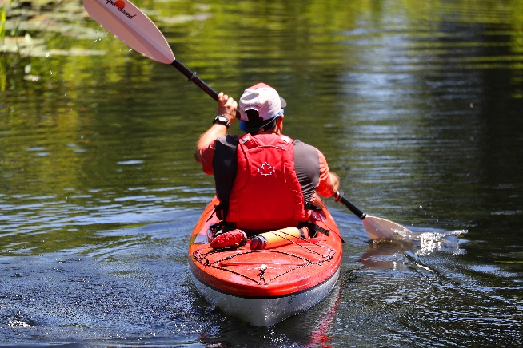
Frontenac County spans four different watersheds, each of which is managed by a separate conservation authority. These agencies are responsible for regulating shoreline and in-water activities/alteration and issuing permits, if required.
Turn on the Boundary layer in Frontenac Maps to determine the Conservation Authority.
- Cataraqui Region Conservation Authority
- Quinte Conservation Authority
- Rideau Valley Conservation Authority
- Mississippi Valley Conservation Authority

Water and Sewage Services
There are no municipal water or sewer services within Frontenac County, with the exception of the village of Sydenham, which has municipal water services. That means each property must have sufficient space to accommodate both on-site water (well) and sewage (septic system) services. When considering purchasing property which contains existing development it is important to ask questions about the age and condition of these items. For more information on septic systems you can refer to the Septic Smart Handbook.

New Lot Creation
Sometimes the ideal property for your vision does not exist and you may be considering severing a new lot (consent application) from an existing parcel. There are many factors which will affect the ability to create a new lot including: official plan designation, current zoning of the property, existing lot area, road/water frontage, number of previous severances, natural features and ability to accommodate on-site services. Please contact the Planning Department of the Township in which you are interested for further information on this process.

Other Considerations
Beyond planning, you may wish to consider a number of other aspects about the property and neighbouring area. You may wish to ensure adequate utility, internet, and cellular services and consider nearby recreation facilities. You may also consider having a survey completed to understand the property boundaries. As the potential purchaser, we advise you do your due diligence before making a large investment!

