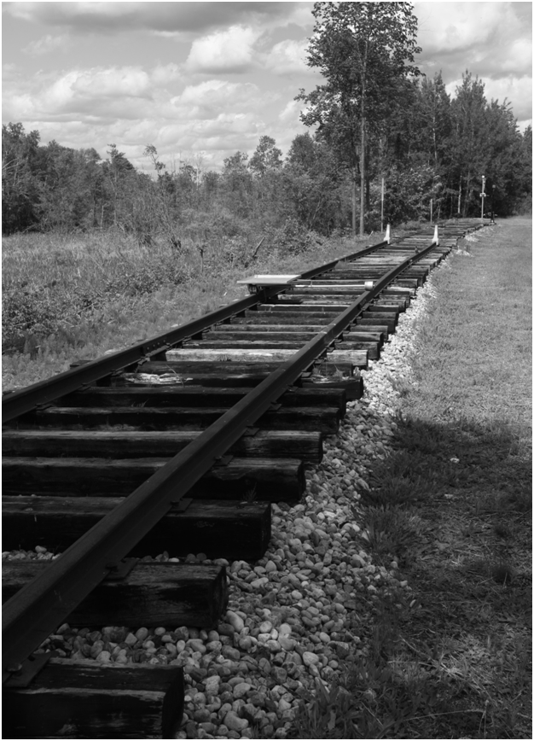

County of Frontenac Official Plan

Adopted October 15, 2014

MMAH Approval January 11, 2016


County of Frontenac

By-law 2014-0047

Adoption of an Official Plan for the County of Frontenac

As Amended By:

By-law No. | Title | Date of Passage | Date of MMAH Approval
 | Ministry of Municipal Affairs Notice of Decision |  | January 11, 2016
2016-0014 | Official Plan Amendment No. 1 (to correct technical errors) | April 20, 2016 | October 21, 2016

Office Consolidation – April 21, 2016

County Official Plan – Policy Outline

Section 1 – Introduction

  - Purpose, Basis, and Context of County Plan 7
  - How to Read the Plan 13

Section 2 – Economic Sustainability

  - Natural Resources 16
    - Agriculture
    - Mining and Mineral Aggregate Resources
      - Mineral Mining
      - Mineral Aggregates
    - Forestry
    - Renewable Energy
      - Introduction
      - Policies

  - Built Resources 21
    - Commercial
    - Tourism
      - Introduction
      - Policies
    - Business Parks

Section 3 – Growth Management

3.1 Growth Projections for Frontenac County 23
3.1.1 Employment
3.1.2 Housing Supply
3.2 Settlement Areas 24
3.2.1 Introduction
3.2.2 Settlement Area Policies
3.2.2.1 General
3.2.2.2 Settlement Area Boundary Expansions
3.3 Rural Lands 26
3.3.1 Introduction
3.3.2 Objectives
3.3.3 Policies
3.3.3.4 Special Policies – Waterfront Areas
3.3.3.4.1 Introduction
3.3.3.4.2 Goal
3.3.3.4.3 Objectives
3.3.3.4.4 Policies
3.4 Crown Lands 31

Section 4 – Community Building

  - Transportation 33
    - Roads
      - Introduction
      - Goal
      - Regional Road Network
      - Provincial Highway 7
      - Provincial Highway 41
      - Private Roads
    - Rural Public Transportation
4.1.2.1 Introduction
4.1.2.2 Goal
4.1.2.3 Policies
    - Pedestrian
      - Policies
    - Trail Development
      - Policies
      - Special Policies: K & P Trail
4.1.4.2.1 Policies
    - Ferry Services
      - Background
      - Policies
    - Scenic Routes

  - Servicing 40
    - Long Range Planning for Municipal Services
      - Introduction
      - Goal
      - Objectives
      - Policies
4.2.1.4.1 Special Policies: Future Village Services Planning
4.2.1.5 Private Services
    - Storm Water Management Planning
      - Introduction
      - Policies
  - Waste Management 44
    - Introduction
    - Goal
    - Objective
    - Policies
  - Utility and Communications Facilities Corridors 45
    - Introduction
    - Policies
  - Community Improvement Plans 46
    - Introduction
    - Goal
    - Objectives
    - Policies
4.5.4.1 Special Policy – Regional Community Improvement Plans
  - Parks and Open Space 47
    - Introduction
    - Policies

Section 5 – Housing and Social Services

5.1 Municipal Housing Strategy 49
5.1.1 Introduction
5.1.2 Policies
5.2 Affordable Housing 50
5.2.1 Introduction
5.2.2 Policies
5.3 Seniors Housing 51
5.3.1 Introduction
5.3.2 Policies
5.4 Group Homes 52
5.4.1 Introduction
5.4.2 Policies
5.5 Homes for the Aged (Long Term Care Complexes) 52
5.5.1 Introduction
5.5.2 Policies
5.6 Secondary Suites 53
5.6.1 Introduction
5.6.2 Policies
5.7 Accessibility 53
5.7.1 Introduction
5.7.2 Policies

Section 6 – Heritage and Culture

  - General Policies Land Claim 55
  - Archaeological Resources 56
  - Algonquin Aboriginal Interest 56
    - Policies
  - Rideau Canal UNESCO World Heritage Site 59
  - Frontenac Arch UNESCO Biosphere Reserve 59

Section 7 – Environmental Sustainability

  - Natural Environment 61
    - Introduction
    - Goal
    - Objectives
    - Policies
      - Wetlands
      - Significant Areas of Natural and Scientific Interest (ANSI)
      - Significant Wildlife Habitat
      - Fish Habitat
        - Lake Trout Lakes
      - Endangered and Threatened Species
      - Significant Woodlands
      - Significant Valleylands
      - Linkages and Biodiversity Areas
        - Linkages
        - Biodiversity Areas (Overlay)
      - Mineral Aggregate Operations
      - Environmental Impact Study
      - Land Uses and Zoning
      - Stewardship Planning
      - Lake Management Plans
  - Water Resources 75
    - Source protection Plans
  - Hazard Lands 76
    - Introduction
    - Natural Hazards Policies
    - Human-Made Hazards

Section 8 – Implementation

  - Interpretation of Land Use Designation Boundaries 79
  - Amendments to the Plan 79
  - Amendments to the Township Official Plans 80
  - Public Participation 80
  - Zoning By-laws 80
  - Subdivision and Condominium Approvals and Agreements 80
  - Planning Applications – Consultation and Complete Application
Requirements 81
  - Development Charges 82
  - Land Use Compatibility 82

Schedule “A” – Land Use Map
Appendices
Appendices “1A to 1C” – Natural Heritage System
Appendix “2” – Designated ‘At Capacity’ Lake Trout Lakes
Appendix “3” – Environmental Impact Study Requirements

SECTION 1 - INTRODUCTION

1.1 Purpose, Basis and Context of the Plan

Purpose
The Frontenac County Official Plan creates the framework for guiding land use changes in the County over the next 20 years to 2034 by protecting and managing the natural environment, directing and influencing growth patterns and facilitating the vision of the County as expressed through its residents. This Plan also provides the avenue through which Provincial Policy is implemented into the local context. The Plan is also a major cornerstone in the implementation of Directions for Our Future, the County’s sustainability plan.
Basis
The Official Plan for Frontenac County has its basis in the Planning Act; the Provincial Policy Statement (2014); and the four sustainability pillars identified in Directions for Our Future.
Context of the Plan
Without question Frontenac County is characterized by a predominantly rural landscape with small communities such as Plevna, Cloyne, Ompah, Sharbot Lake, Verona, Harrowsmith, Sydenham, Marysville, Howe Island and many more villages and hamlets throughout the geography.
The County has one of the smallest populations of all counties in Eastern Ontario. The County surrounds the City of Kingston to the north and south and extends beyond Highway 7 northerly towards the Madawaska River and Renfrew County and to the south across Wolfe and Howe Islands to the United States border on the southern side of the St Lawrence River. In terms of surrounding local governments, the Frontenacs are bounded to the east by the Counties of Lanark and Leeds & Grenville, to the north by Renfrew County, and the west by Lennox & Addington County.
In terms of municipal government, the County is composed of four lower-tier municipalities – the Townships of South, Central and North Frontenac and Frontenac Islands. (See Figure 1 – Local Municipalities)
The small population (26,600) and the large geographic area of the Frontenacs (4,000 km²) result in a low population density. There are only small communities. Of the settlement areas in the County the largest villages have between 200 to 300 homes within their boundaries. In terms of demographics, the number of retirees is increasing as is the number of seasonal residents, in part because of the spectacular natural features of the County. On the other hand, the trends show young people continue to move away, to larger urban centres.
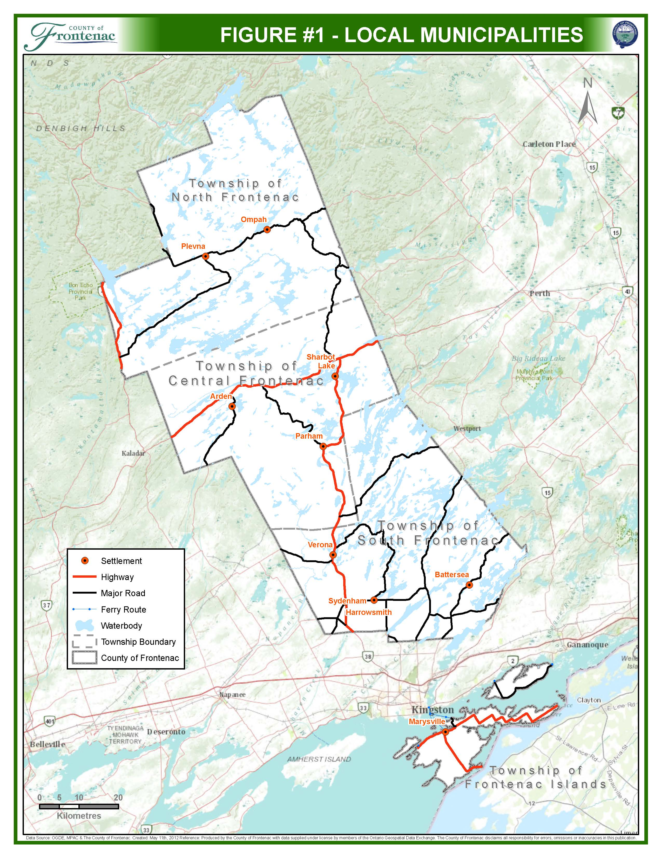

Because the population lives predominately in villages or rural areas, municipal services, such as water and wastewater systems are not provided (with the exception of the water system in Sydenham). As a result, access to clean, reliable drinking water is an issue for some residents. The small size of the communities also means that residents may need to travel to urban centres for health and professional services, cultural and recreational opportunities.
The County boasts some of the most beautiful natural features to be found in Ontario, possessing 1000 lakes, Wolfe and Howe Islands that form part of the 1000 Islands, and stretches of uninterrupted forests that include Frontenac and Bon Echo Provincial Parks. The attractiveness of these features draws seasonal residents, outdoor recreationists, and artists, artisans and craftspeople. These people all seek nature for their own reasons, whether it is for adventure and exploration, peace and solitude, or inspiration. The tourism sector is also strongly linked to a pristine environment. The Frontenacs are home to enviable natural resources such as numerous lakes and islands, protected areas, an uninterrupted night sky, and a world renowned biosphere.
In addition to the many lakes within Frontenac, the major waterways of the Cataraqui, Salmon, Mississippi, Napanee, and Fall Rivers all cross through part of the County, and both Wolfe and Howe Islands along with a number of smaller islands are located on the St. Lawrence River at the exit from Lake Ontario. The Rideau Canal system, a designated UNESCO World Heritage site, travels through the southeastern part of the County. The Frontenac Arch Biosphere Reserve is one of sixteen biospheres in Canada and is designated under UNESCO’s Man and Biosphere Programme; it covers parts of the United Counties of Leeds and Grenville and Frontenac County, including portions of Central and South Frontenac Townships. All of these features reinforce the value of the natural heritage system we have in the Frontenacs.
The wealth of our natural resources is reinforced by the amount of Crown land, lakes, rivers, and wetlands that are within the County. Figures 2 to 4 illustrate the location and amount of these resources throughout the Frontenacs.
Frontenac County’s history is rich in agricultural activity which continues today in the form of commodity farms, small family farms, hobby farms, horse ranches, forestry and other specialty farms. The agricultural roots of the community are celebrated in fairs, ploughing matches, church socials, and other events. Agriculture continues to play an important role in the County’s economy.
The Frontenacs are also at the forefront of renewable energy in Eastern Ontario, the most visible project being the eighty-six wind turbines located across Wolfe Island. Over the past few years, numerous ground-mounted and roof-mounted solar panels have been set up on homes, businesses and farms throughout the County.
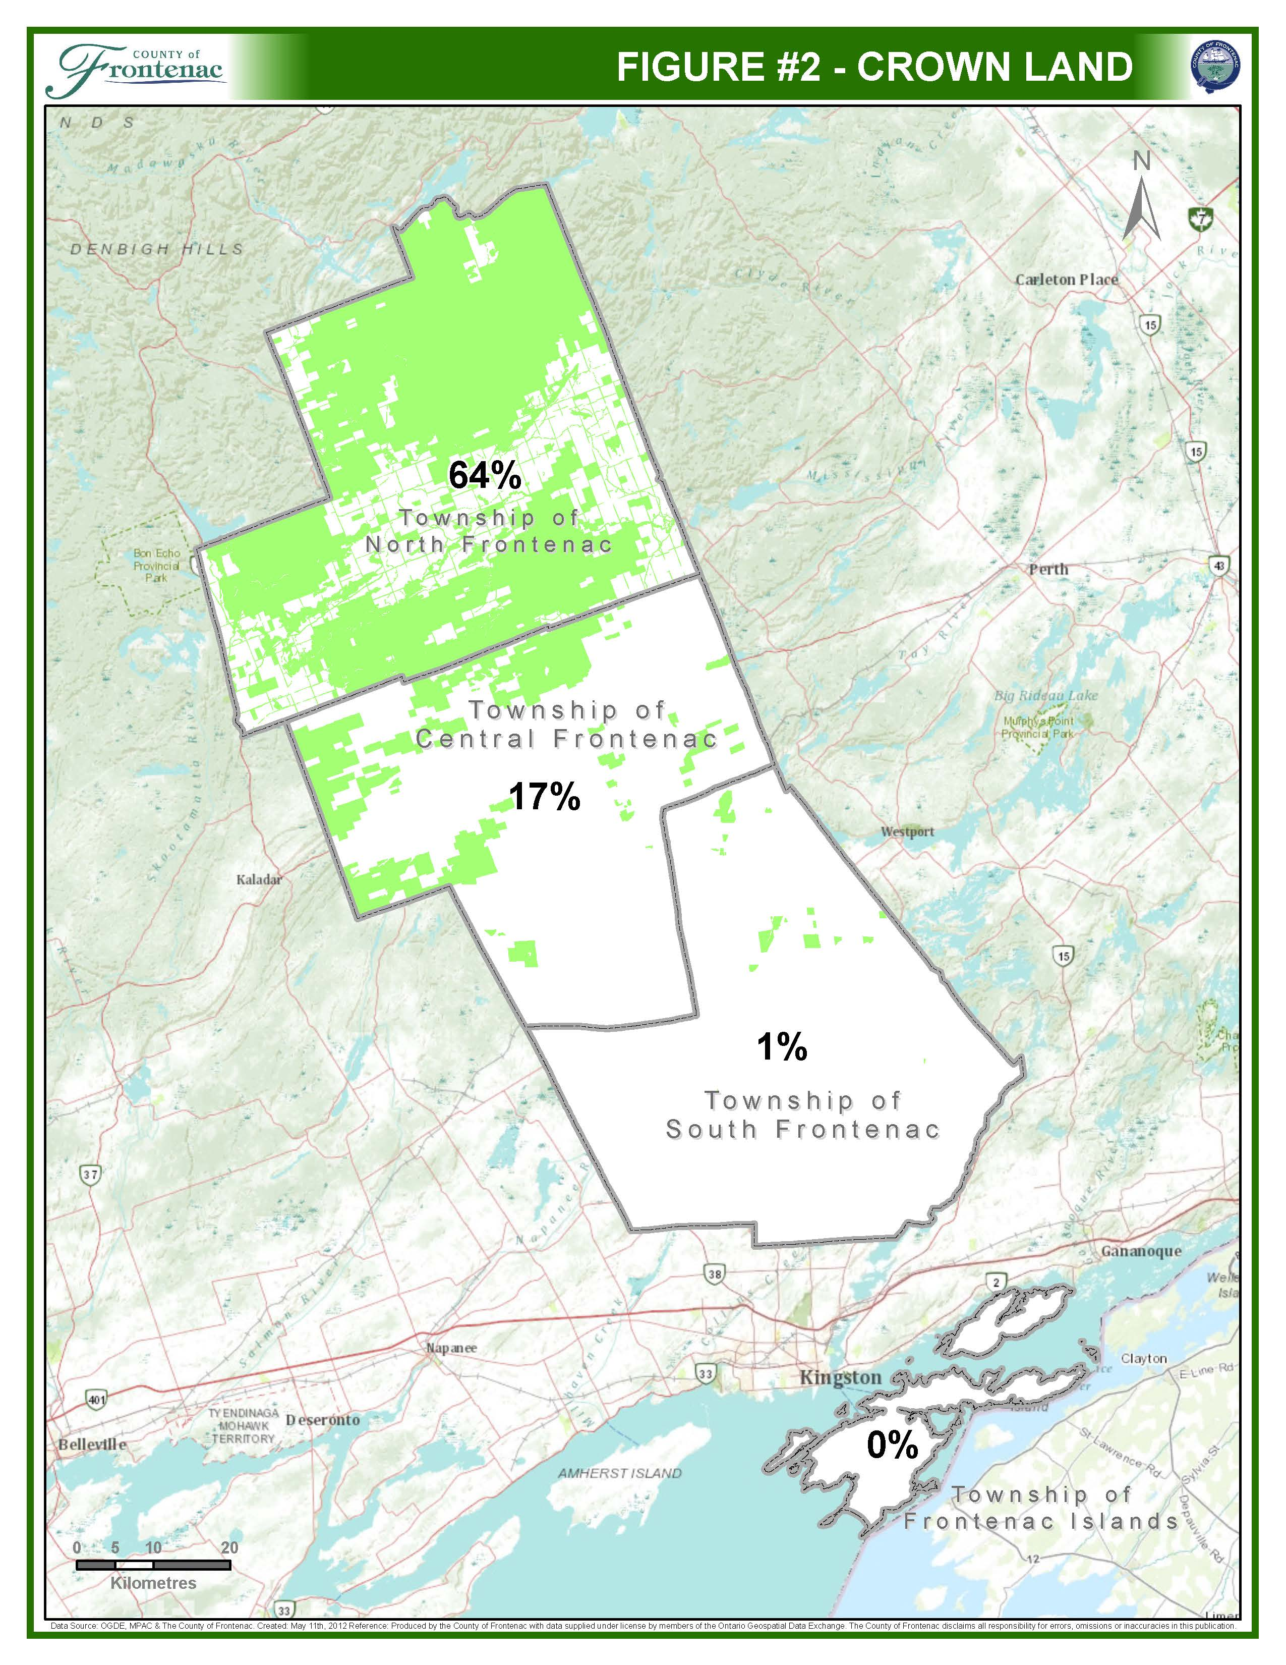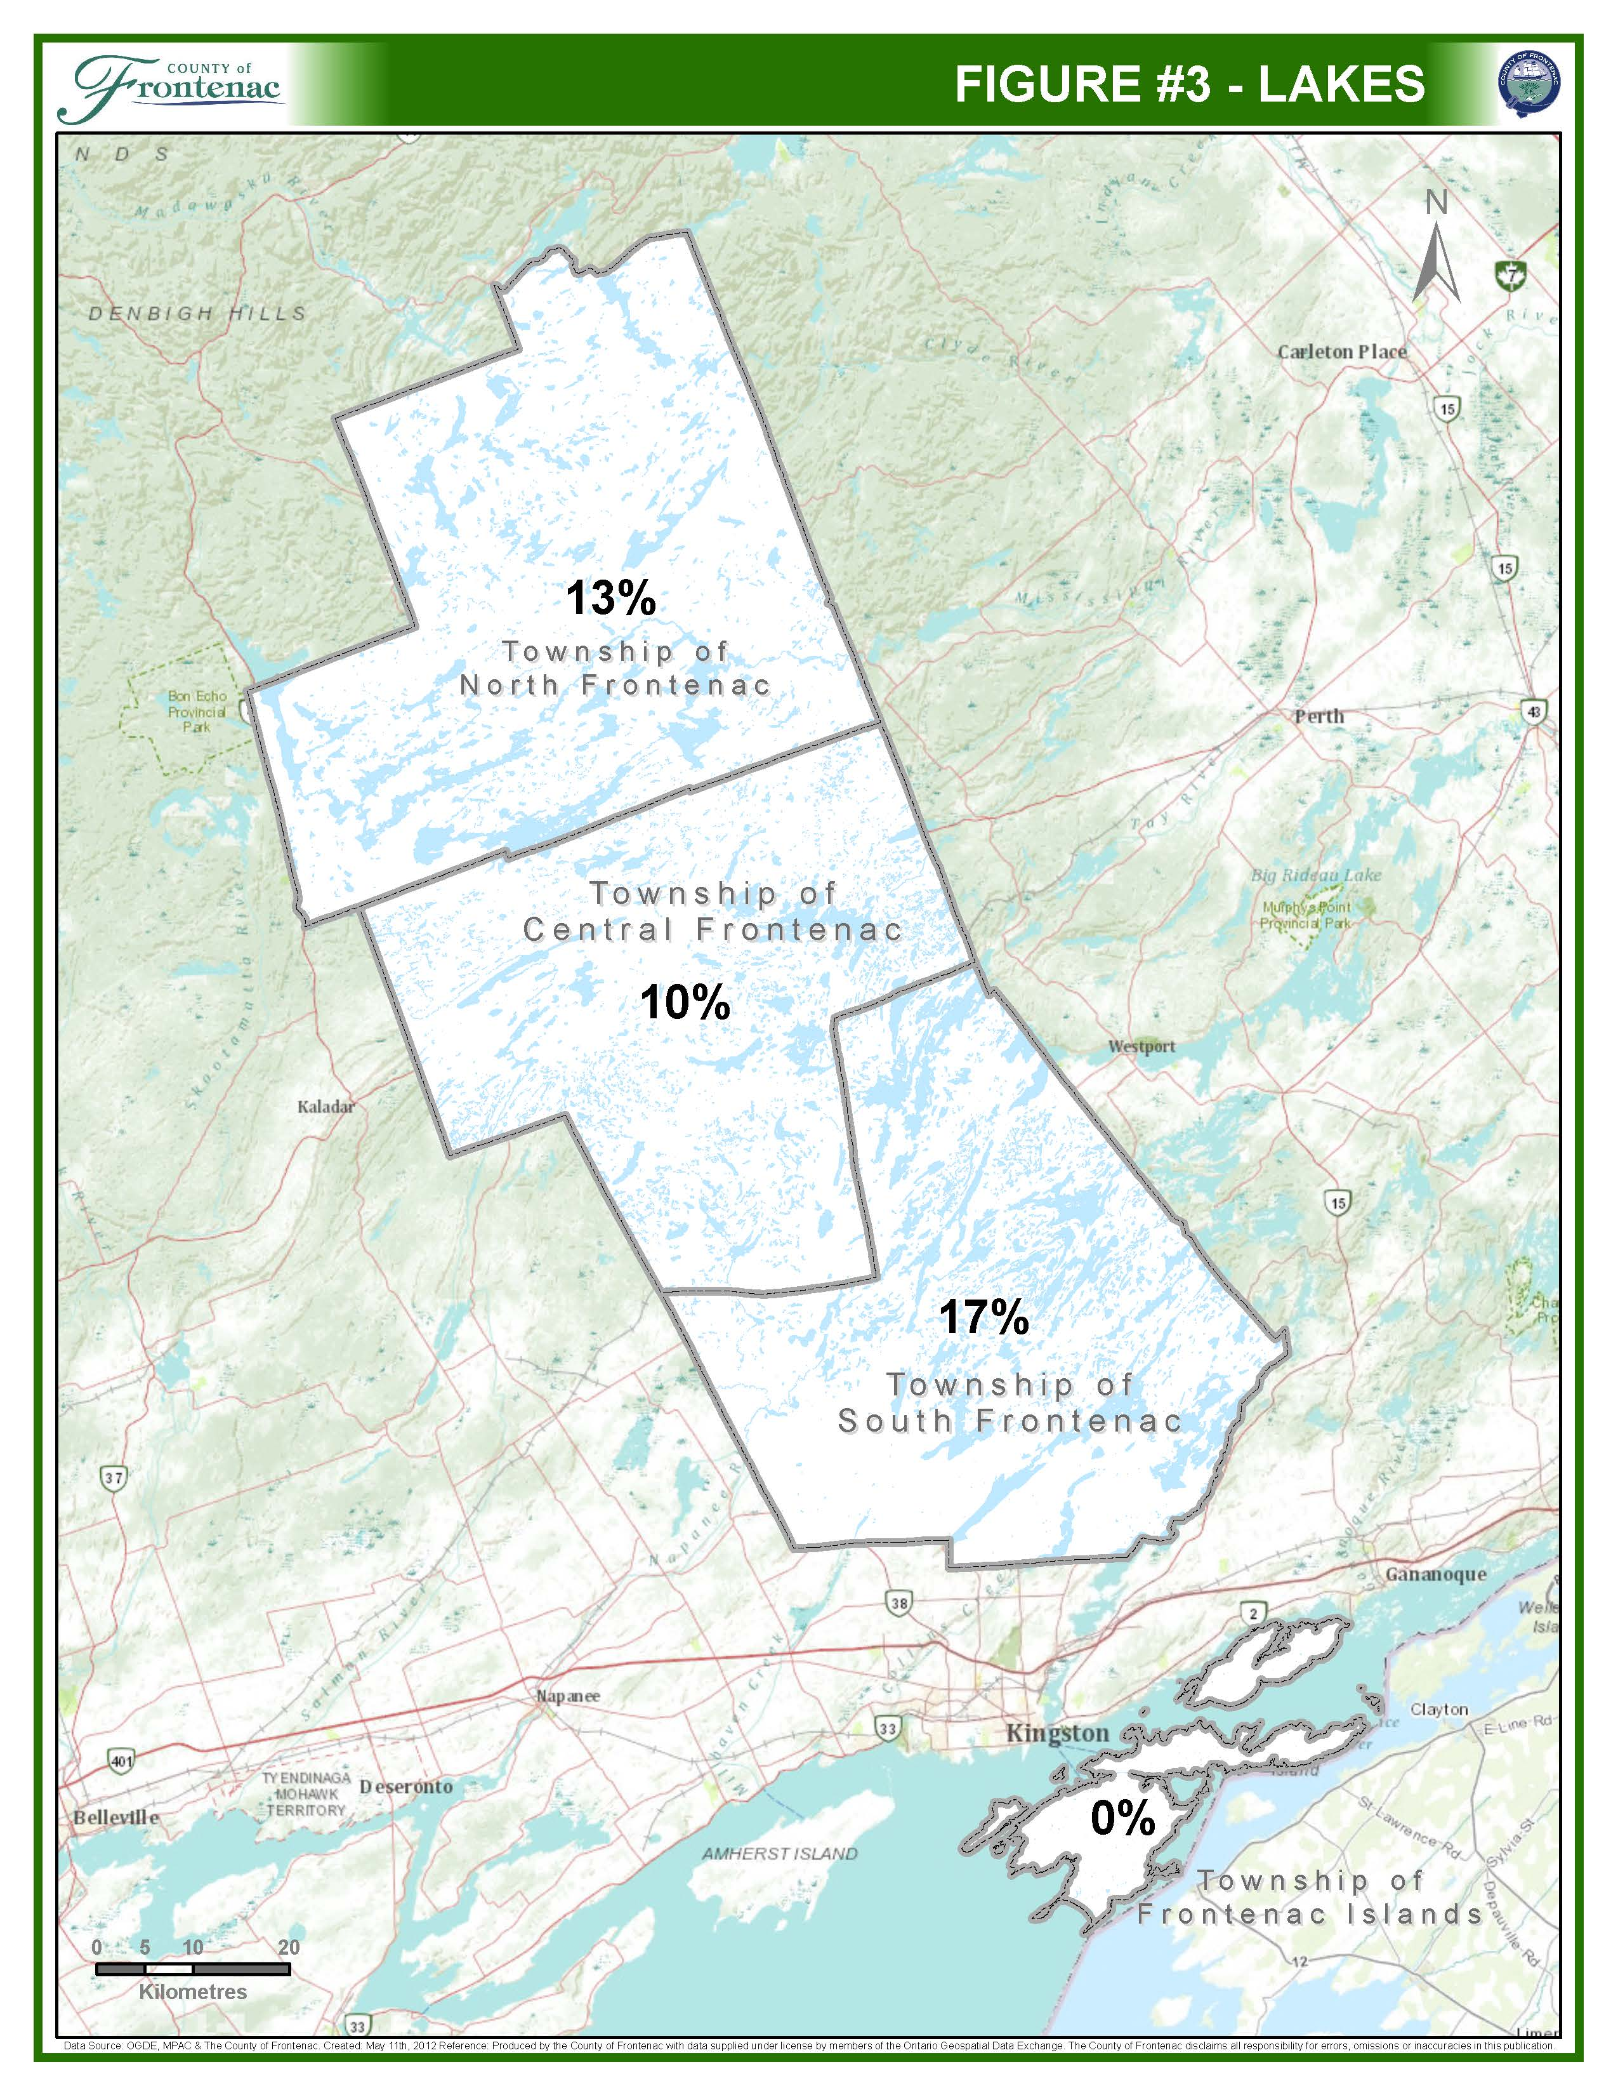
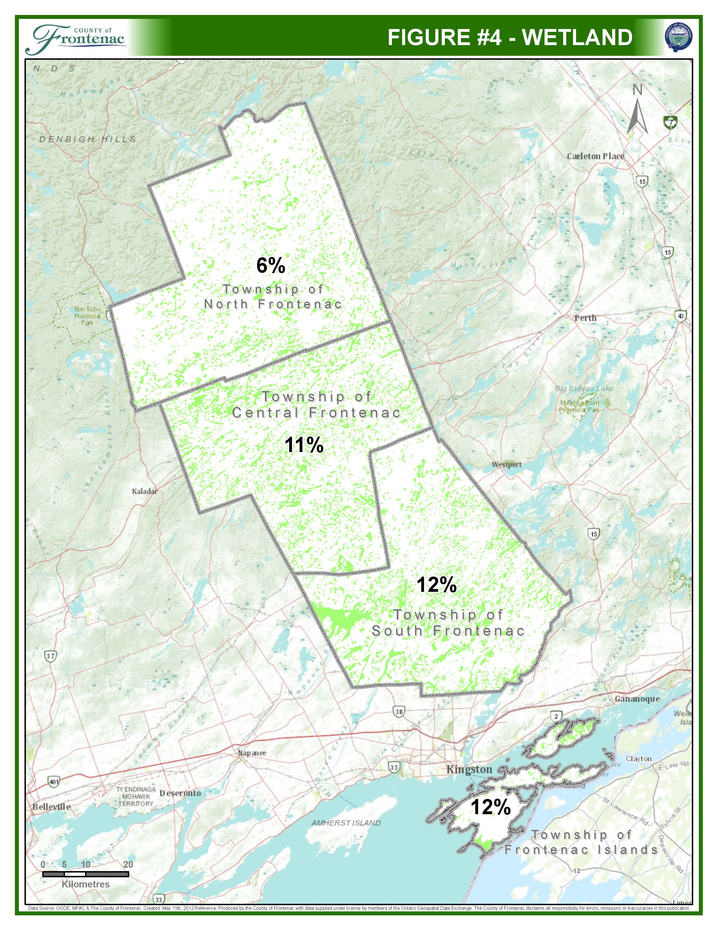
1.2 How to Read the Plan
This Official Plan is prepared by the County of Frontenac to guide the actions of local municipalities and the County in policy planning and physical planning on a broad ‘high level’ basis. It is based on a watershed planning approach as set out in Figure 5.
The County Plan serves as the upper tier Official Plan for the County. It establishes a vision in which planning and sustainability protect and enhance the natural landscape, rural lifestyle, and sense of community for the Frontenacs.
This document, hereafter is referred to as “the Plan” or “this Plan” implements a strategic approach to land use planning based on a watershed planning process. This Plan sets out the general direction for planning and development in Frontenac County by defining strategic goals, broad objectives and policies.
It is the intention of the Plan to set the context for planning in the County as a whole and provide regional direction on planning issues.
It is not the intention of the Frontenac County Official Plan to interfere with those planning matters which are considered to be the responsibility of the local municipalities. Local municipal Official Plans complement the Frontenac County Official Plan by providing detailed strategies, policies, and land use designations for planning and development at the local level.
The structure of the Plan is based on six sustainability themes. Each of the themes is developed to function as part of the building blocks that encourage a sustainable balance between the economy, community building, and the environment.
The Economic Sustainability theme highlights the natural resources of the Frontenacs and the best management practices for developing and managing those resources for future use. This theme also covers the built economy and how economic practices of commercial, tourism, and industrial type development should take place. Trying to develop a strong and diverse economy in Frontenac County is a major component of these building blocks.
In the future, the County may undertake an enhanced regional role concerning matters which cross municipal boundaries and are considered to be of a County wide/or Provincial interest. This may include conducting County wide studies on cross-jurisdictional issues and enhanced policy direction on matters such as, but not limited to, mineral aggregate resources, source protection planning and economic development.
(MMAH Approval dated January 11, 2016)
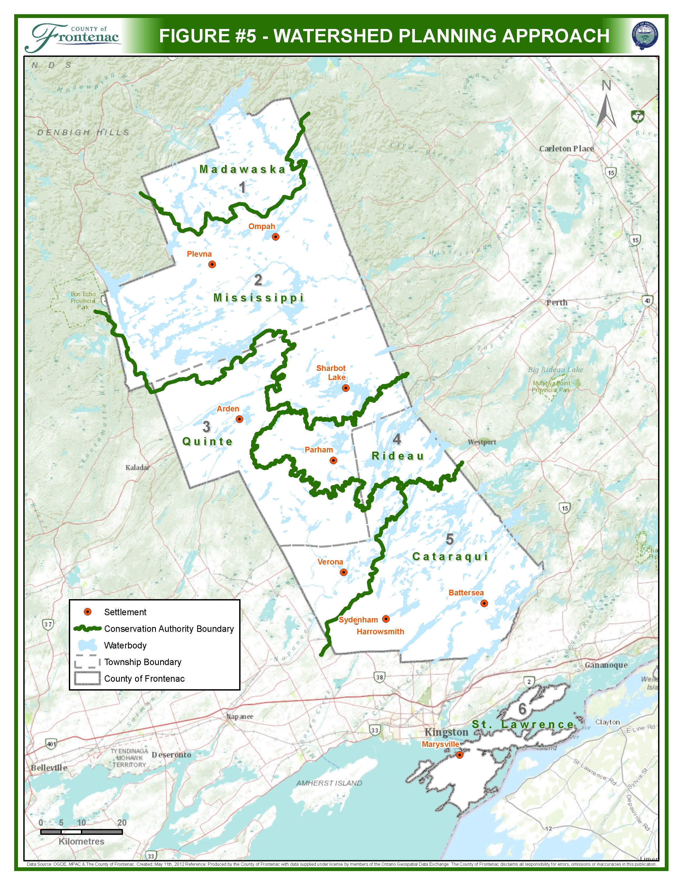
The Growth Management theme deals with future residential development in the County, using the County-wide growth projections as a starting point. This section will include policies to support existing hamlets and new development in rural and waterfront areas.
Community Building is a theme that has the goal of encouraging the development of our community through interaction, collaboration, and cohesiveness. This includes supporting a regional road system, trail development, and ideas for pedestrian movement and rural transit – all of these issues are essential to strengthening both communities and the strength of the economy.
Housing and Social Services will focus on key regional housing issues that are recognized in the Kingston-Frontenac County Municipal Housing Strategy and which are especially important over the long term to the rural area, including seniors housing and affordable housing.
The Heritage and Culture theme has the goal of encouraging identification and conservation of cultural heritage resources that are valued for the important contribution that they make to our understanding of the history of places, events, or people in the Frontenacs. This theme will also include policies with regard to the Algonquin Land Claim which covers a large portion of the north and central part of the County and which will result in a variety of potential land use changes in the future.
The Environmental Sustainability theme identifies significant natural areas that need to be protected and managed to form a basis for future land use decisions. A level of protection for the environment is required under Provincial policy to ensure development is sustainable to ensure a healthy and high quality of life for existing and future residents of the County.
Appropriate policies for each sustainability theme are included in the Plan to ensure all aspects necessary for a healthy community are protected, managed and made available to existing and future residents.
In addition to the six themes that form the bulk of the policies in the Official Plan, there are two other sections which follow that complete the Plan:
- The Implementation and Interpretation section which describes interpretation and implementation tools available to the County through the Planning Act, public participation, and consultation for planning applications; and
- The Mapping section which contain Schedule(s) which show the location of the Official Plan designations for all of Frontenac County as well as the regional natural heritage system.

SECTION 2 – ECONOMIC SUSTAINABILITY

The Economic Sustainability section is divided into two pieces. The first piece identifies policies relating to the natural resources of the County. The significant natural resources include agriculture, mineral aggregates, forestry, and renewable energy.
The second subsection highlights policy directions relating to those economic activities stemming from the natural and built environment such as commercial, tourist and potential business park development.
Both of these sections highlight the importance of these sectors to the economic health of Frontenac County.
  - Natural Resources
2.1.1 Agriculture
Introduction
A prime component of the County’s economy is the extensive area of lands that are used for farming, both in prime agricultural and rural areas. Farming is fundamental to the economic base and rural lifestyle of the County. It is in the County’s interest to preserve that lifestyle and to foster the agricultural community. The land base should be protected and the use of the lands must be predominantly agriculturally oriented to achieve these objectives. The farming community forms a core economic basis for the rural community

Policies
1. The agricultural community should be fostered and protected to ensure its viability for the economic and social benefit of the County. In order to accomplish this the County will encourage the Townships to:
a) protect the prime agricultural land for agricultural purposes; and
b) encourage the development of agricultural support services within designated hamlets.
2. Local Official Plans shall identify and protect prime agricultural areas.
(MMAH Approval dated January 11, 2016)
3. Value-Added Uses – land uses that add value to farm products may also be permitted on farms in both Agricultural and Rural designations. For these types of uses located in Prime Agricultural Areas designated in the Township Official Plans, the Agriculture – Permitted Uses section of the Provincial Policy Statement (PPS), shall apply. These uses may include processing, preserving, storing and packaging of farm products and outlets for the retail sale of agricultural products from the farm operation on the property. Facilities that add value to farm products may be used co-operatively; however, the scale of operations may not exceed the needs of the surrounding agricultural community and will be secondary to the farming activity of the property. The size of the building or facility for these uses will be limited in the implementing zoning by-law of each Township.
(MMAH Approval dated January 11, 2016)
4. The standard for separating residential uses from existing, new or expanding livestock facilities shall be the Minimum Distance Separation (MDS) formulae, as revised from time to time. The MDS formulae shall also be used when considering the creation of new lots and new development in proximity to livestock facilities. Notwithstanding policies relating to new developments on existing lots of record, where there is a vacant lot of record that is impacted by MDS, a dwelling may be permitted provided the dwelling is located on the lot at the furthest distance possible from the impacted livestock facilities. The MDS formulae shall apply in both the rural and prime agricultural land use designations in the Township Official Plans, outside of settlement areas.
(MMAH Approval dated January 11, 2016)
5. The Townships shall designate Prime Agricultural Areas in their respective Official Plans in accordance with the Provincial Policy Statement (PPS)
(MMAH Approval dated January 11, 2016)
6. The Townships shall permit agricultural uses, agriculture-related uses and on-farm diversified uses in Prime Agricultural Areas in their respective Official Plans in accordance with the Provincial Policy Statement (PPS).
(MMAH Approval dated January 11, 2016)
7. The Townships may only permit lot creation and lot adjustments in Prime Agricultural Areas in their respective Official Plans in accordance with the Provincial Policy Statement (PPS).
(MMAH Approval dated January 11, 2016)
8. The Townships may only permit non-agricultural uses in Prime Agricultural Areas in accordance with the Provincial Policy Statement (PPS).
(MMAH Approval dated January 11, 2016)
9. The Townships may only permit extraction in Prime Agricultural Areas in their respective Official Plans in accordance with the Provincial Policy Statement (PPS).
(MMAH Approval dated January 11, 2016)
    - Minerals and Mineral Aggregate Resources
The County of Frontenac contains many unique minerals and aggregate resources. Mineral and mineral aggregate deposits and operations will be protected. Local official plans will identify mineral and mineral aggregate resources, protect them from incompatible uses so their future use is ensured and establish buffer areas where incompatible development is not permitted. These resources are identified in Appendices ‘1D’ and ‘1E’ of the Plan.
(MMAH Approval dated January 11, 2016)
The following policies are intended to address both mineral mining operations as well as mineral aggregate extraction.
2.1.2.1 Mineral Mining
- Mining and related activities shall only be permitted outside identified settlement areas.
- The creation of new mining and mining related activities shall be subject to the approval of the Ministry of Northern Development and Mines under the Mining Act and the Environmental Protection Act, and shall be subject to local Official Plan policies and local Zoning By-law regulations.
- An ‘Influence Area’ shall be used in order to protect existing land uses in the vicinity of a proposed mineral mining operation. This ‘Influence Area’ shall also be applied to protect mineral mining operations from the encroachment of incompatible land uses. Local Official Plans shall establish the extent of an influence area in consultation with the Ministry of Northern Development and Mines and the Ministry of the Environment and Climate Change (MOECC). Development may be permitted in an ‘Influence Area’ as set out in Local Official Plans and only where the impacts of a mining operation can be properly mitigated.
(MMAH Approval dated January 11, 2016)
2.1.2.2 Mineral Aggregates
Frontenac County has a variety of mineral aggregate deposits. The County recognizes that these non-renewable resources are an important component of the economy of the County which must be protected for future use. It is also recognized that the extraction of the aggregates must be undertaken in an environmentally sound manner that adequately protects significant natural environment features and minimizes community disruption.
- Mineral aggregate resources shall be recognized and managed by the Local Official Plans. These resources shall be mapped on Township Official Plan Schedules.
(MMAH Approval dated January 11, 2016)
- Recognizing that mineral aggregate resources cross municipal boundaries, the County will undertake a mineral aggregate resources study, in consultation with the Ministry of Natural Resources and Forestry to identify unconstrained aggregate resources that are a high priority for protection. The findings of this study shall be implemented through Official Plan Amendment. In the interim, the County and the Townships shall use the Township Official Plans and Appendix 1D and 1E to identify aggregate resources.
(MMAH Approval dated January 11, 2016)
- The Townships, in consultation with the Ministry of Natural Resources and Forestry (MNRF) and the Ministry of Northern Development and Mines shall review development proposals with respect to mineral aggregate resources.
(MMAH Approval dated January 11, 2016)
- The Townships shall identify and protect all existing mineral aggregate operations from incompatible uses and activities that would preclude or hinder their expansion or continued use, or which would be incompatible for reasons of public health, public safety, or environmental impact. The Townships shall map the locations of all existing licensed mineral aggregate operations on their official plan land use schedules and zoning by-laws. Existing mineral aggregate operations shall be permitted to continue without the need for an official plan amendment, rezoning or development permit under the Planning Act.
(MMAH Approval dated January 11, 2016)
- Within or adjacent to known deposits of mineral aggregate resources, development and activities which may preclude or hinder the establishment of new operations or access to the resources may only be permitted if:
- Resource use would not be feasible; or
- The proposed land use or development serves a greater long-term public interest; and
- Issues of public health, public safety and environmental impact are addressed.
The County or the Townships may require the completion of a study by a qualified professional to demonstrate that the proposed use is consistent with the above policies for development proposals. For the purposes of the above policy, adjacent lands shall be those lands contiguous to lands on the surface of known deposits of mineral aggregate resources where it is likely that development would constrain future access to the resources. The extent of the adjacent lands shall be identified in Township Official Plan and may be recommended by the Province.
(MMAH Approval dated January 11, 2016)
    - Forestry
Council shall consider the incorporation of “good forestry practices” along with the impact of the development on the ability to provide a continuous, sustainable forestry industry in the County.
For the purposes of this Plan, “good forestry practices” means the proper implementation of harvest, renewal and maintenance activities known to be appropriate for the forest and environmental conditions under which they are being applied and that minimize detriments to forest productivity and health, and the aesthetics and recreational opportunities of the landscape. Good forestry practices will ensure that no forest values are diminished by protecting key stand components and by minimizing environmental damage during tree harvesting. Properly managed tree harvest activities shall assure the maintenance of all forest values and a continuous flow of forest products that provide for both short and long‐term economic benefits to landowners. Similarly, forest management plans should recognize and recommend mitigation measures on the impacts of forestry operations on the tourism industry and visual amenities of the County.
In partnership with County and local governments, forestry operators will consider developing an inventory of forest resources.
Forest operators will consider undertaking sustainable approaches and are encouraged to develop sustainable forestry plans which may include the development of a plan for rehabilitation and reforestation to preserve the biodiversity and ecological health of the region.

2.1.4 Renewable Energy
2.1.4.1 Introduction
One of the primary ‘focus areas’ of Directions for Our Future deals with the future of energy demand and production in the Frontenacs. The objective is to reduce the amount of energy consumed over the next generation, combined with renewable energy production and encouragement. It is hoped that conservation measures combined with clean, low-impact electrical generation will contribute to a gradual shift away from the reliance on fossil fuels.
2.1.4.2 Policies
The County is committed to further the community’s vision of the ‘Energy Focus Area’ in Directions for Our Future.
The County and the Townships will be encouraged to work collaboratively to assist in Green Energy activities such as municipal solar installation, energy conservation, community power, and other related projects.
The County will support the creation of a Community Energy Plan for the Frontenacs to encourage local energy production and increase community capacity with renewable energy.
The County will support economic development opportunities in the local energy sector as they arise.
The County will promote energy conservation to the public and will seek opportunities to facilitate conservation.
  - Built Resources

2.2.1 Commercial
Commercial development in Frontenac County is identified under two general policy areas. Both types of commercial use are important for ensuring that a wide range of commercial opportunities as possible exist for County residents, seasonal and year round alike, as well as tourists staying in or traveling through Frontenac County. The two general types of commercial development are:
a) Community Commercial which consists of the business district and historic crossroad or core of each urban area, and also includes highway commercial which serves both travelling and local public; and
b) Resort Commercial uses which provide for commercial facilities and services for tourists and seasonal residents.
The Townships will establish appropriate commercial land use policies in their respective Official Plans.
    - Tourism
2.2.2.1 Introduction
Tourism and leisure opportunities are some of the key aspects to Frontenac County’s economy. This sector includes, but is not limited to, golf courses, resorts, campgrounds, trailer parks, marinas, tourist accommodation facilities, museums, historical and scenic tours and heritage sites. The many lakes and rivers in the Frontenacs play a significant role in providing opportunities for tourism and leisure activities.
2.2.2.2 Policies
The County will work with the local Townships, the Province, Frontenac Community Futures Development Corporation (CFDC), the City of Kingston, and various tourism agencies and organizations to promote tourism activity.
The County will continue to work on development of a regional trail network to help create a recreational use that will travel through the Frontenacs and act as a regional tourist destination.
The County will work with and support tourism-related projects with all of the Townships that are of benefit to tourists and to the community.
    - Business Parks
Frontenac County currently has a very small industrial base. The majority of industries make up small pockets of uses in the agricultural, rural, and hamlet areas. These uses include home-based activities.
Directions for Our Future also recognizes the opportunity of a new business park in the County as a key economic pillar of sustainability. It notes that the possibility of developing a green business park would be beneficial in having infrastructure in place for businesses considering relocation and could also act as a catalyst by grouping businesses as a hub.
There are very few planned business parks designated in the four Township Official Plans. This Plan recognizes the importance of the goal of attracting businesses to the County to encourage local job creation and investment in the rural economy.
The following policies should be considered as part of the location and development of a business park(s) in the Frontenacs:
- In order to ensure appropriate and efficient access, business parks should be located on or close to one of the regional roads that are identified on Schedule ‘A’ (Land Use);
- A business park development proposal should consider the following development policies:
- Business parks may include buildings designed for individual or multiple occupancy on a leasehold or condominium basis;
- Business park development may occur on a multiple lot basis or as a single land parcel with single or multiple buildings; and
- Buildings in a business park should be designed to a similar and high-quality standard to promote an attractive setting.
- The County and/or the Townships may assist in the creation of a business park in the following ways:
  - land acquisition and site preparation;
  - development of the infrastructure to prepare the business park for development, such as power, servicing, lighting, road construction, and broadband connection;
  - the preparation of any planning, engineering or other studies to ensure the business park is developed to appropriate standards; and
  - municipal fiscal incentives to encourage new development such as grants to cover the costs of building permit fees or development charges.

Section 3 – Growth Management
The Growth Management section sets out policies that are intended to help guide new development (residential and non-residential) across Frontenac County. The policies are intended to manage change from a regional level.
The Growth Projections section allocates population and employment growth across the Frontenacs to 2034.
(MMAH Approval dated October 21, 2016)
The Hamlets section is intended to support and strengthen existing communities and their infrastructure.
Rural Areas policies are intended to recognize the importance of the rural areas of the Frontenacs for future growth and to create guidelines for new development that will be sensitive to its surroundings.
Waterfront Development policies will recognize the importance of the abundant lakes and rivers within the Frontenacs and the need to protect the natural environment and character of these areas for future generations and to also establish parameters for new development along or near the water.
3.1 Growth Projections for Frontenac County
In 2014 the County completed the Population, Housing and Employment Projections for the Frontenacs. The projections indicate that the permanent population base of the County is forecasted to steadily increase over the next 25 years from 27,900 in 2011 to 32,900 in 2034.
A share of the population and household unit growth is projected throughout the four Townships in the County. Also included is projected growth of the seasonal population of the County, which has a significant influence throughout the Frontenacs but especially in the northern portion. The future share of household growth is allocated upon a number of factors including:
- Frontenac County’s adjacency to the City of Kingston will allow some areas of the County, notably South Frontenac Township, to attract new growth. South Frontenac is allocated 70 % of the projected growth of permanent population in the County because of the employment opportunities available in the city;
(MMAH Approval dated January 11, 2016)
- The remaining growth shall be allocated accordingly: Frontenac Islands (7%), Central Frontenac (16%) and North Frontenac (7%).
(MMAH Approval dated October 21, 2016)
- The lack of full municipal water and wastewater services in any of the hamlets or villages of the County will constrain the ability to increase the density of these areas, and may impact the ability to focus new development within these settlement areas;
(MMAH Approval dated January 11, 2016)
- Rural residential development will continue to be an important component of household growth in the County, given that overall residential development is projected to be limited. Demonstration of limited rural residential development in Township Official Plans may include such measures as limits to the number of lots granted through consent and plans of subdivision; and

(MMAH Approval dated January 11, 2016)
- The population, housing and employment forecast will be monitored and reviewed periodically to determine its accuracy. Adjustments to the forecasted growth will be made during the five year reviews of the Official Plan; and

- Settlement areas are identified in the Provincial Policy Statement (PPS), 2014 as villages and hamlets where development is concentrated and which have a mix of land uses. It is recognized that some of the historical settlement areas identified on Schedule ‘A’ of this Plan may not meet this definition and are better described as crossroad. As a result, the County will undertake a settlement area study to examine and rationalize settlement areas identified on Schedule ‘A’ in order to determine where growth shall be focused over the long term planning horizon.
(MMAH Approval dated January 11, 2016)

3.1.1 Employment
In order to meet the long term needs of the County by providing a mix and range of employment opportunities, the County shall explore ways to enhance the local employment base in strategic locations such as settlement areas and along major transportation routes.
(MMAH Approval dated January 11, 2016)

3.1.2 Housing Supply
The land and residential unit supply in the lower-tier official plans shall reflect the growth allocations set out in this section and be consistent with the regional marketing housing requirements of Section 1.4.1 of the PPS.
(MMAH Approval dated January 11, 2016)
  - Settlement Areas
3.2.1 Introduction
As Frontenac County has developed over time, it contains of a number of small villages and hamlets, scattered rural housing, waterfront cottages and homes, and rural subdivisions. There is no village or hamlet that has full municipal services. The village of Sydenham had water servicing installed in 2006 to service the existing community.
These settlement area policies are intended to set a planning framework that will encourage and support the existing Settlement Areas, both mixed use and primarily residential.
The policies will allow each Township to have the ability to develop their communities based on local characteristics and needs, as well as fiscal capacity. The policies also recognize that due to the lack of municipal water and sewer services, the County supports new development in both the settlement areas as well as in rural locations.
Settlement area locations are identified on Schedule “A“of this Plan.
3.2.2 Settlement Area Policies
3.2.2.1 General
Based on its historic settlement pattern, Frontenac County has many villages and hamlets scattered throughout the region. Some of these villages have a mix of residential, commercial, and institutional uses, while other hamlets are primarily residential and small in size. Traditionally, these communities have developed as residential, social and commercial centres serving the surrounding agricultural, mining, or forestry community. While this traditional role will continue to be encouraged, it is also recognized that changes and improvements to transportation facilities over time have lessened the emphasis on hamlets as rural service centres and increased their role as residential settlements.
The following general policies shall apply to Settlement Areas which are identified on Schedule ‘A’ of this Plan:

- Local Official Plans shall designate Settlement Areas and determine their boundaries.

- Efficient development patterns and road connections will be encouraged in Settlement Areas to optimize public services and to make the most efficient use of land and resources.

- Local Official Plans shall, where feasible, promote mixed use development in Settlement Areas including residential, commercial, institutional, parks, and employment areas.

3.2.2.2 Settlement Area Boundary Expansions
The County’s long term prosperity, environmental health, and social well-being depend on wisely managing change and promoting efficient land use and development patterns. On this basis, Settlement Area boundary expansions shall be determined by the Local Official Plans and shall require an Official Plan Amendment to the Local Plan. As none of the Settlement Areas in the Frontenacs have full municipal services, a settlement area capability study (comprehensive review) is required by this Plan for any boundary expansion to determine:
  - that the Settlement Area can adequately accommodate new development without having a negative impact on groundwater used for drinking purposes and/or the ability of the soils in the area to assimilate effluent;
  - the potential impacts of new development on the road network and other municipal infrastructure such as community facilities;
  - justification for the need to expand the settlement area;
  - an analysis of alternatives that may be considered to settlement expansion, including redevelopment and infill; and
  - a review to determine compliance with the Minimum Distance Separation (MDS) formulae.
It is not anticipated that any of the settlement areas in the Frontenacs will require expansion in the life of this plan. If a settlement area expansion is being considered, in addition to the aforementioned criteria, the settlement area expansion policies of the Provincial Policy Statement (PPS), shall apply.
(MMAH Approval dated January 11, 2016)
3.3 Rural Lands
3.3.1 Introduction
The Rural designation comprises all lands outside of settlement areas in the County that are not:
- Natural Heritage Areas or other natural resources listed in Section 7;
- Resource Lands such as minerals, mineral aggregate, forestry, and prime agricultural set out in Section 2.1.; and
- Waste Disposal Sites
(MMAH Approval dated January 11, 2016)

Traditionally, these lands have been utilized as an alternative location for those persons preferring a rural residential lifestyle.
These non-resource lands have also provided a location for commercial and industrial uses requiring a location in the rural area because of land use requirements and/or proximity to natural resources. The Rural designation also includes areas containing viable farming operations that need to be protected, through the application of the MDS I and II formulas.
Low density residential development as well as rural-related commercial, industrial, recreational and institutional development is desirable, provided it is appropriately located. The Rural designation is intended to guide rural type development while at the same time protecting the rural character, heritage and natural resources of the County. In addition, the designation is intended to manage growth in an environmentally and fiscally responsible manner.
More specifically, on rural lands, permitted uses are:
  - The management and use of resources;
  - Resource-based recreational uses (including recreational/cottage dwellings);
  - Residential development of a limited scale;
  - Home based industries and home occupations;
  - Cemeteries
  - Other rural land uses that are compatible with the nature of the rural area.
(MMAH Approval dated January 11, 2016)
Development shall proceed in accordance with the policies of Section 4.2 – Servicing, Section 6 – Heritage & Culture and Section 7 – Environmental Sustainability.
(MMAH Approval dated October 21, 2016)
3.3.2 Objectives
(1) To preserve the open space, rural character, topography and landscape of the rural area;
(2) To promote rural living in a manner sensitive to the ecological balance, sensitive to the farming and forestry communities and sensitive to the protection of groundwater and surface water quantity and quality;
(3) To maintain economic stability in the County by considering factors such as municipal servicing limitations, environmental factors, compatibility of land uses, and land capability when reviewing development proposals;
(4) To promote the tourism economy of the County by ensuring suitable lands are available to satisfy demands for tourism and tourism-related development;
(5) To encourage economic diversification including greater flexibility for on-farm activities, home-based businesses, and agri-tourism, and new small scale industrial-type ventures that are connected to the farm economy such as milk processing, cheese factories, and craft breweries; and
(6) To preserve the farming community as an important economic and cultural resource for the Frontenacs;
3.3.3 Policies
(MMAH Approval dated January 11, 2016)
- In recognition of the potential impacts that new growth and development may have on entire watershed systems, the County encourages communication between the local Townships within the same watershed area when a new development proposal is considered to have a potential impact on the quality and function of the watershed.

- Residential development is permitted in the Rural designation in accordance with the following policies:

  - Lot creation should take place either through Plan of Subdivision, Plan of Condominium, or Consent;
  - Rural residential development shall reflect the intent of preserving the rural, open space character of the County. This will mean that, to the extent possible, the appearance of such development should be unobtrusive and blend in with the rural landscape.
  - New residential development should not be located on lands which would involve major public expense in opening up or maintaining access routes, providing drainage, or providing other public services and facilities, unless major public services, access, and/or facilities are provided at the developer’s expense.
  - It is recognized that the majority of existing and new rural residential development will be serviced by private wells and septic tanks; however, the County and the Townships may be interested in the investigation of new technologies and communal servicing options where it is deemed feasible for such areas and is supported by the Ministry of the Environment and Climate Change (MOECC).
(MMAH Approval dated January 11, 2016)
  - In determining the location and suitability of any proposed residential plan of subdivision, the following criteria shall be considered by both the County and the Townships:
    - the design of the subdivision should provide for a range of lot sizes directly related to the site’s topography, vegetation and soil and drainage characteristics;
    - based on the varying topography across the County, the Local Official Plans should establish a base minimum lot size;
    - the minimum area of lot sizes should be determined by a hydrogeological study and a terrain analysis;
    - the subdivision should have direct access to a public road that is maintained year round and is improved to acceptable municipal standards;
    - Lots need to be of adequate size to provide for proper installation of private services;
    - Any proposed subdivision should not land lock any other adjacent parcel of land, and future connection links to adjacent properties shall be provided where determined appropriate;
    - In order to maintain the rural character of the landscape, the development should be located in areas having natural amenities such as varied topography, mature tree cover, scenic views and should blend in with the natural landscape so that the rural environment is left relatively undisturbed;
- Rural residential development should avoid locating on lands having significant agricultural capability and near areas where any significant impact on established agricultural activities will occur; and
- The use should be compatible with adjacent land uses.
3.3.3.4 Special Policies -- Waterfront Areas
3.3.3.4.1 Introduction
Frontenac County is blessed with hundreds of lakes and rivers covering its geography, including pristine lakes on the Canadian Shield, Lake Ontario and the Saint Lawrence River waterbodies surrounding Wolfe and Howe Islands, as well as the southern section of the Rideau Canal National Historic Site and UNESCO World Heritage Site.
In terms of sustainability, waterfront protection covers all four ‘pillars’ contained in the County’s sustainability plan, Directions for Our Future: social, cultural, environmental, and economic.
Cottage development and tourist operations have developed on many of the County’s lakes and rivers since the early twentieth century. While originally summer areas with basic cabin structures, more and more buildings have been converted to year round use and the majority of new development is being built to be habitable all year. Almost all of this development relies on private water and sewage systems.
For the purposes of this Plan, Waterfront Areas shall generally include all lands extending inland 150 metres (500 feet) from the ordinary high water mark of any lake, river, or waterway. This is a general boundary intended to recognize that development within this area may have an impact on lake quality and those impacts may need to be considered for any development within the boundary. Lands and land uses that are more than 150 metres from shore but which are physically or functionally related to the Waterfront Areas shall be considered to be part of the Waterfront Area. All lands that are less than 150 metres from shore but which do not physically or functionally relate to the Waterfront Areas are not considered to be part of a Waterfront Area. The entire areas of islands, excluding Wolfe and Howe Islands, shall normally be considered to be part of a Waterfront Area. The Waterfront Area shall not extend into any Settlement Area identified in this Plan, or into any prime agricultural or other agricultural areas that are identified in the Township Official Plans.
(MMAH Approval dated January 11, 2016)
3.3.3.4.2 Goal
The overall goal of this Plan is to improve and protect the waterfront areas in Frontenac County as a significant cultural, recreational, economic, and natural environment resource and to maintain or enhance the quality of the land areas adjacent to the shore.
3.3.3.4.3 Objectives
- To encourage appropriate public access to Waterfront Areas where accessibility is permitted;
- To permit shoreland development that allows for sustainable growth of existing and new tourist developments and innovative and appropriately designed new residential developments;
- To protect and enhance the heritage character of the Rideau Canal National Historic Site and UNESCO World Heritage Site and its associated cultural and natural heritage resources and scenic landscape setting;
- To maintain or improve water quality on a watershed-wide basis;
- To ensure that the built form along a shoreline is not overly concentrated or dominating to the detriment of the natural form;
- To maintain, enhance and/or restore the majority of the developed and undeveloped shorelines in their natural state by promoting property stewardship; and
- To preserve and enhance fish and wildlife habitat areas and other natural heritage features that are within and along Waterfront Areas.
3.3.3.4.4 Policies
- The character of Waterfront Areas is linked to the natural and built form that is associated with the lakes and rivers in the County. Generally the natural form includes vegetated shorelines with thin soils over bedrock. The built form is predominated by residential development including resorts and marinas. In this context, new development or redevelopment occurring in the Waterfront Areas should, where possible enhance and protect those qualities that contribute to the area’s character;
- All Waterfront Areas should be considered to be a major recreation resource area that, where appropriate, should be accessible to both public and private users;
- Shoreline alterations shall require approval by the municipality and/or the appropriate agency (Conservation Authority, Ministry of Natural Resources and Forestry (MNRF), Canada Fisheries and Oceans, Parks Canada). Township Official Plans may include shoreline alteration policies that are more restrictive than those of the approval agencies;
(MMAH Approval dated January 11, 2016)
- The County may participate with the Townships and/or community groups and cottage associations in promoting public responsibility for water quality and the visual objectives of shoreline management on a watershed basis;
- The County will encourage and support lake associations to conduct lake stewardship planning. Any such lake plan may be considered as part of the input to planning decisions at the Township level;
- Tree cover and vegetation is encouraged to be retained along the shoreline to maintain the visual and environmental integrity of Waterfront Areas. Where development is proposed along shorelines, Township Official Plans should contain policies relating to the preservation of a natural undisturbed buffer between the water’s edge and new development;
- To maintain the shoreline character and water quality, Local Official Plans and Zoning By-laws shall require that all new development and leaching beds be set back at least 30 metres (100 feet) from the ordinary high water marks of all waterbodies. Any proposed reduction to the 30 metre minimum setback shall be in accordance with policies in Local Official Plans which establish criteria for considering such reductions. A setback of greater than 30 metres from the ordinary high water mark may be required in some locations; and
- Township Official Plans shall include criteria for determining an appropriate setback where an existing lot of record cannot achieve the minimum setback of 30 metres (100 feet). However, the greatest setback possible will be required.
3.4 Crown Lands
Crown lands are a significant resource for the County and most of the local Townships. The policies in this Plan are not binding on Crown land activities; use of Crown land will be determined by the Province with regard for established planning policies of the County and the local municipalities. Local official plans will contain policies that state that where Crown land becomes privately-owned, the policies of the Official Plan apply. Township official plans shall map Crown lands as a distinct land use category on their Schedules. Conversion will not require an amendment to the County Official Plan but change of use following disposition may require an amendment to the Local Official Plan and/or Zoning By-law.

Section 4 – Community Building
The Community Building section sets out policies that are intended to help ensure that the public infrastructure that ties the region together and is key to its sustainability can be maintained and possibly enhanced over the next twenty years. The provision of transportation, water, waste water, and solid waste is crucial to ensuring that Frontenac County can accommodate any future growth in a manner which is environmentally, socially, and economically sustainable.
This Plan recognizes that it is the responsibility of the local municipalities to plan, construct, and maintain most of the public infrastructure. Continued efforts to find solutions to local infrastructure problems by local municipalities are considered appropriate and in conformity with the policies of the County Official Plan. County Council may also consider undertaking regional level studies in order to help plan future capital improvements.
The Transportation section sets out the vision for a regional transportation system that is key for helping citizens and visitors move through the Frontenacs, including roads, transit, trail development, pedestrian safety, ferries, and important scenic routes.
The Servicing section is intended to establish a long-term approach to dealing with servicing in some of the County’s villages to ensure safe and plentiful drinking water. The section also contains policy direction for applying storm water management over a watershed area.
Solid Waste Management policies are intended to recognize the importance of long term planning for waste management across the County and to support a collaborative approach to ensure a positive outcome from both an environmental, economical, and health perspective.
Transmission Corridors and Communication/Telecommunication Facilities policies will establish a set of general policies for direction to Provincial and Federal agencies to reduce incompatibility with the existing County land base.
The Community Improvement Plan policies will establish goals and objectives for creating new plans throughout the County, and supporting County Council’s financial investment as a basis for local improvements.
The Parks and Open Space policy section will recognize the importance of providing a full range of parks, open space, and recreational facilities for the enjoyment, health and welfare of Frontenac residents as a means of increasing the County’s appeal as a tourist destination. It will also recognize the importance of Crown lands and Provincial Parks as recreation resource areas.
Infrastructure, electricity generation facilities and transmission and distribution systems, and public service facilities shall be provided in a coordinated, efficient and cost-effective manner that considers impacts from climate change while accommodating projected needs. Planning for infrastructure, electricity generation facilities and transmission and distribution systems, and public service facilities shall be coordinated and integrated with land use planning so that they are:
- Financially viable over their life cycle, which may be demonstrated through asset management planning; and
- Available to meet current and projected needs.
Public service facilities should be co-located in community hubs, where appropriate, to promote cost-effectiveness and facilitate service integration, access to transit and active transportation.
(MMAH Approval dated January 11, 2016)
4.1 Transportation
4.1.1 Roads
4.1.1.1 Introduction
Frontenac County is served by an extensive road network that includes municipal roads that serve both a local and regional purpose as well as Provincial Highways 7 and 41 which travel across the upper portion of the County. Following municipal amalgamation in 1998, more than 400 kilometres (250 miles) of Provincial Highways and County Roads were downloaded to the four Frontenac Townships. As a result, it is the responsibility of each Township to carry the financial cost of maintaining and repairing these roads, including those roads which handle regional traffic which were never designed for local traffic.
The importance of our roads in maintaining and improving the economy of Frontenac County cannot be underestimated. The Frontenacs are dependent on the road system for the movement of goods and services, as well as for access to health and social services and for tourism use.
      - Goal
The goal of recognizing a County-wide road network is to support the long-term viability of a regional road system to ensure access throughout the Frontenacs and connections to the surrounding region.
4.1.1.3 Regional Road Network
This Plan identifies a regional road network on Schedule “A”. These are roads that are recognized as having regional importance in moving people and goods within and outside the County. It is recognized that these roads are owned and maintained by each of the four local Townships. It is the intention of County Council to recognize that this road system is an essential part of the infrastructure that supports the County.
The County supports a cross-jurisdictional collaborative approach to managing and maintaining these regional roads, and to develop a transportation system that will encourage unity within the County and will satisfy local municipal transportation demands.
The County will investigate and support all senior government programs that will provide financial investment in the regional transportation infrastructure.
The County supports collaboration with the City of Kingston on efforts to maintain and improve road connections between the County and the City.
4.1.1.4 Provincial Highway 7
Highway 7 is identified on Schedule “A“. Highway 7 is a Provincial Highway that runs east-west through the middle of the County just north of the main village of Sharbot Lake. Historically, Highway 7 has been an important transportation route within Frontenac County. As growth continues in the Greater Toronto Area as well as the Ottawa Region it is expected that Highway 7 will undergo changes and handle additional traffic. The County will support improvements to Highway 7 that enhance safety and convenience for its residents and the travelling public.
Highway 7 is designated by the Province as a special controlled access highway. Any development adjacent to or impacting Highway 7 requires the issue of permits from the Ministry of Transportation so that the long term function of the highway is maintained.
The Highway 7 / Highway 38 intersection is an important commercial node for both the travelling public and for local residents. The County supports the continued viability of this area and any policies or measures to strengthen the commercial uses at this intersection. The County will support and work with the Township of Central Frontenac on any measures to request the Ministry of Transportation to reduce speed levels through this area for safety and also to allow for easier access to the stores and gas stations at this intersection.
4.1.1.5 Provincial Highway 41
Highway 41 is identified on Schedule “A" and is the major north-south link in the northwestern part of the County. It provides access to Bon Echo Provincial Park and contains many services for residents and cottagers in the northern Frontenac County. Highway 41 is a Provincial Highway that provides access to Pembroke and beyond, and should continue to be maintained by the Province.
4.1.1.6 Private Roads
The County is undertaking a private roads study in 2016. The results of this work will assist the County and its lower-tiers in developing a measurable and enforceable mechanism aimed at creating reasonable and safe development of private roads.
(MMAH Approval dated January 11, 2016)
4.1.2 Rural Public Transportation
4.1.2.1 Introduction
Providing public transportation options in a rural setting such as Frontenac County is challenging. The rural transportation problem is based on the fact that residents need mobility of some form in order to access their basic needs in a rural context, where distances are long and people and services are spread out. Transportation of some form is essential. Frontenac County is not unique in that reliable alternatives to the automobile to a large degree do not exist, and transportation access directly equates to personal vehicle access or ownership.
Transportation provides access to social programs, pharmacies, banking facilities, post offices, and health centres. In terms of economic development, public transportation can provide access to training, education, and employment opportunities that allow people to remain living in the rural area of the Frontenacs.
4.1.2.2 Goal
To provide a safe, convenient, effective transportation system for all citizens of Frontenac County, including those citizens who do not have access to a personal vehicle.
4.1.2.3 Policies
The County will support efforts to develop a public transportation system that is sustainable in the long term and which is based on four cornerstones of a functional system: affordability; availability; accessibility; and acceptability.
The County recognizes and supports the efforts of Frontenac Transportation Services (FTS) to provide volunteer-led transportation for individuals throughout the Frontenacs. County Council will consider a longer term investment (e.g., five years) to FTS to allow it to plan services beyond an annual basis.
The County will explore alternatives and consider various rural transportation models that could be effective in the context of the rural density of the Frontenacs, including community-based models.
The County will work with community groups such as community care organizations, charities, and volunteers to review their potential involvement and operation of a rural transportation system.
The County will investigate various funding options from senior levels of government and other organizations to operate and maintain a public rural transportation system.
The County will work with the Townships to support carpooling initiatives and the development of new and expanded carpool lots along major transportation routes, including the Road 38 corridor, Perth Road, Battersea Road, and/or Sydenham Road.
The County will investigate collaborative operations with the City of Kingston to improve public transportation options into the rural area of the City and into the County.
The County encourages the development of transit-supportive communities in order to increase the future potential of efficient rural transit in the Frontenacs. This includes the creation of active transportation connections within and between settlement areas and the clustering of transit-supportive uses such as schools, businesses, social services, and health facilities within settlement areas.
    - Pedestrian
4.1.3.1 Policies
Providing facilities for convenient pedestrian movement is important. The provision of sidewalks on one side of local roads and both sides of collector and arterial roads is encouraged wherever practical.
To encourage pedestrian travel, streetscapes in villages and hamlets should be safe, convenient, and attractive for pedestrians. This may include providing sidewalks, locating commercial uses at street level, providing appropriate lighting, street furniture, landscaping, and ensuring that it meets accessibility requirements.
Sidewalks are encouraged in conjunction with the development of new roads within settlement areas.
The County will encourage the development and enhancement of pedestrian trails throughout the Frontenacs, including multiple use trails.
The County supports trail routes created by a linked system between community facilities and major parks and open space areas.
    - Trail Development
4.1.4.1 Policies
County Council recognizes that trails (both for walking and cycling) can provide significant health, transportation, environmental, and economic benefits, including the following:
  - Active transportation modes use no fossil fuels and emit no gas emissions;
  - Cycling and walking provide an enjoyable, convenient, and affordable means of travel;
  - Physical activity improves cardiovascular and mental health, and is linked to the prevention of a number of diseases; and
  - Cycle tourism can benefit the economy of businesses across the Frontenacs.
The County’s goal is to establish a well-connected system of trails throughout the Frontenacs that will provide residents and visitors the opportunity to engage in active healthy lifestyles, to travel to key destinations, and experience the vistas provided by the County’s natural features and cultural resources.
The County supports trail routes created by a linked system between community facilities and major parks and open space areas.
The County will use the County of Frontenac Trails Master Plan (2009) to direct trail development, uses, location, and implementation that will guide future development of a trails system for the next 20 years.
The County will build on existing trail systems in the Frontenacs, including the Frontenac K&P Trail, the Rideau Trail, and the Cataraqui (TransCanada) Trail, to connect into the County’s hamlets and villages, roads and waterbodies, with the goal of developing a user-friendly network.
The public shall be consulted on trail development and the implementation of routes and facilities.

The County will use the following trail selection principles as a basis for new trail creation:
  - Safety
  - Visibility
  - Destination-Oriented
  - Attractive and Scenic
  - Connectivity
4.1.4.2 Special Policies: K & P Trail
The Frontenac K&P Trail is named after the Kingston & Pembroke Railway, a rail line that was built from Kingston to Renfrew between 1871 and 1885. The railway was established by a local group of Kingston businessmen who wanted to see the construction of a rail line north to the Ottawa Valley for the purpose of gaining access to the natural resources (logging and mining) and to potential markets in the north. The expected volume of rail activity never materialized and the railway was eventually purchased by the Canadian Pacific Railway in 1901. Over time the entire line was abandoned, with the final active portion between Tichborne and Kingston shut down in 1986.
The Frontenac K&P Trail right-of-way runs in a north-south direction across the mainland of the County and into the City of Kingston. The County owns a large portion of the southern section of the right-of-way, other portions are owned by North and Central Frontenac Townships, and other portions are privately owned. To the south, the City of Kingston owns the K&P right-of-way and has converted the majority of it to an active trail which the County trail can connect into.
Conversion of the rail right-of-way to an active trail began in 2012 with the trail developed between Orser Road – connecting with the City trail – north to Highway 38 just south of Harrowsmith.
The main purpose of the Frontenac K&P Trail is to develop a trail spine through the Frontenacs that can provide linkages with other trails throughout the area.
The completion of the Frontenac K&P Trail through to the developed portion of the K&P which starts in the Township of Central Frontenac at Sharbot Lake, travels through the Township of North Frontenac, into Lanark Highlands and finally meeting up with Greater Madawaska south of Calabogie, will greatly enhance trail systems in the Frontenacs and recognize our rich heritage.

4.1.4.2.1 Policies
The County will use the K&P Implementation Plan (2009) as the guiding policy document to direct trail development, uses, land acquisition, and phasing program to guide the development of the K&P trail system.
In conjunction with the Townships the County will endeavour to keep the trail continuous in order to make it more attractive to users and more identifiable as a linear trail. Re-routing may take place where the County does not own the property and an easement agreement cannot be established with the landowner.
The County will work with the City of Kingston to ensure that the K&P trail system is maintained and/or enhanced to a common standard.
4.1.5 Ferry Services
4.1.5.1 Background
The Township of Frontenac Islands relies on ferry services to access the mainland.
Howe Island is served by two ferries: a fifteen car cable ferry located at the west end of the island that is operated by the County and owned and maintained by the Ministry of Transportation which operates on demand on a continual basis and docks at Howe Island Ferry Road in the City of Kingston; and a three car cable ferry (known as the Foot Ferry) located at the east end of the island which also operates on demand over an 18 hour period and which docks at Howe Island Ferry Road East in the Township of Leeds and the Thousand Islands.
Wolfe Island is served by a fifty-five car ferry (Wolfe Islander III) that docks at the Island at both the village of Marysville and, in the winter, at Dawson’s Point, and at the Barrack Street dock in downtown Kingston.
Simcoe Island is served by a three car cable ferry that connects to Wolfe Island.
There is also a privately operated ferry (Horne’s Ferry) that runs from May to October from the south side of Wolfe Island to Cape Vincent, New York.
4.1.5.2 Policies
County Council recognizes that the ferry transportation system is essential to the sustainability of these islands, and that this ferry service is an integral part of Frontenac County’s regional transportation system.
The County will support efforts by Frontenac Islands to maintain adequate service, including:
  - the monitoring of ferry capacity and usage;
  - the review, from time to time, of opportunities to improve the ferry service both through expanded capacity and improvements to infrastructure such as terminals and parking facilities;
  - seeking support from the Province of Ontario in the ongoing maintenance and possible future expansion of ferry operations;
  - consideration of public/private partnerships and development opportunities which would result in a net improvement to access to Wolfe and Howe Islands; and
  - pursue opportunities with neighbouring municipalities in seeking joint solutions which result in ferry access improvements.
The County intends to support and work with the Township of Frontenac Islands in any identification, survey, analysis and design of any ferry facilities expansion or improvement on lands within the City of Kingston to ensure the provision of appropriate vehicle access, pedestrian and bicycle access routes which can be integrated into the City’s transportation system.
    - Scenic Routes
A scenic route or by-way is a specially designated road, waterway, or trail that travels through an area of cultural or natural beauty. Frontenac County’s location and scenic assets provide ample opportunities for creating scenic or heritage routes. These scenic routes draw both local residents and tourists to the scenic areas of the County.
County Council supports the development of scenic routes across the County, and the development of a regional signage strategy to promote these routes.
Scenic routes should be designated for roadways and also for trail systems throughout the Frontenacs.
  - Servicing

4.2.1 Long Range Planning For Municipal Services
4.2.1.1 Introduction
The provision of municipal infrastructure such as roads, street lighting, and municipal water is necessary to support long term viability of the communities located in the Frontenacs.
Frontenac County recognizes the importance of providing municipal infrastructure in a timely fashion and that the maintenance and sustainability of existing infrastructure assets is fundamental to the continued variety and growth of settlement areas across the County.
This Plan recognizes that the responsibility for the planning, construction, and maintenance of municipal infrastructure is the responsibility of the Townships. This Plan also supports the continued revitalization of local infrastructure.
4.2.1.2 Goal
To ensure that there is adequate provision of services and utilities consistent with the environmental, cultural, and economic goals of the County.
4.2.1.3 Objectives
To encourage the provision of adequate municipal services to achieve and facilitate orderly growth.
To improve the natural environment and maintain a clean and healthy level of water quality based on a watershed approach.
To ensure that citizens of Frontenac County have access to potable drinking water.
To promote waste reduction and waste management as per Section 4.3.
To encourage techniques for energy conservation including measures set out in Section 2.1.4
To accommodate growth in an organized manner to minimize capital and operating costs for the Townships.
4.2.1.4 Policies
All new development within Settlement Areas will be provided with appropriate services to sustain permanent occupancy.
The County supports and can work with the Townships to coordinate infrastructure and public service facilities such as potential municipal water and sewage, and will ensure that such facilities are strategically located to support effective and efficient delivery of services across Township boundaries. Accordingly, Frontenac County Council may authorize the development of regional level strategies in order to plan collaboratively for future capital improvements.
Both the County and the Townships will monitor new technologies – in areas such as broadband, water treatment, and septic systems – that would be beneficial to residents and businesses and which would best be coordinated across municipal boundaries and will work together to develop strategies to ensure that optimal services can be provided in a timely and efficient manner.
4.2.1.4.1 Special Policies: Future Village Services Planning
(MMAH Approval dated January 11, 2016)
With the exception of the village of Sydenham, not one of the villages and hamlets in Frontenac County has a municipal water supply. Villages such as Sharbot Lake, Marysville, Verona, Plevna, and Harrowsmith are historical settlements that date back to the mid-nineteenth century in development. Many of the building lots in the village cores are too small relative to today’s health and safety standards with regard to the minimum lot size of approximately 1 hectare (2 acres) to ensure a long term potable water supply on private well and septic systems. The fact that most of the County is set on the Precambrian Shield, which is prone to cracking and seepage, increases the risk of septage movement over a large area. Scientific research has identified the bacteriological contamination of groundwater as a local concern in parts of the Shield area.
Significant investment in public infrastructure is common in all villages in the Frontenacs including road maintenance, sidewalk construction, street lighting, signage, and parks and recreation facilities. Also, the majority of commercial assessment in the County is located in the villages. This reinforces the importance of the stability and improvement of all the County’s villages which serve as community focal points for the surrounding region.
To help ensure that these villages can sustain commercial and residential use and remain a valuable part of sustaining rural living, the County supports long-term planning for potential municipal services in villages. This planning shall include the following:
(MMAH Approval dated January 11, 2016)
- Facilitate the preparation, implementation and monitoring of the Source Water Protection Plans;
- Work with the Townships to investigate and analyze lands adjacent to a village that could be purchased by the County or the Townships for the future site of a municipal well; and further, if necessary, work with the Townships to apply land use controls to surrounding properties to ensure long-term protection of the water source.
- Prepare a region-wide review of villages and hamlets which could require municipal services in the future and develop a priority list for local government investment.
(MMAH Approval dated January 11, 2016)
- Establishment of a County reserve fund for drinking water protection that can be used in the investment of municipal infrastructure for water systems when required.
- Work with provincial and federal governments to seek funding to invest in municipal services.
(MMAH Approval dated January 11, 2016)
- Partial services shall only be permitted in the following circumstances:
- Where they are necessary to address failed individual on-site sewage services and individual on-site water services in existing development; or
- Within settlement areas, to allow for infilling and minor rounding out of existing development on partial services provided that site conditions are suitable for the long-term provision of such services with no negative impacts.
(MMAH Approval dated January 11, 2016)

4.2.1.5 Private Services
Where municipal sewage services and municipal water services or private communal sewage services and private communal water services are not provided, individual on-site sewage services sand individual on-site water services may be used provided that site conditions are suitable for the long-term provision of such services with no negative impacts. In settlement areas, these services may only be used for infilling and minor rounding out of existing development.

Negative Impacts shall be defined for the purposes of this section and Section 4.2.1.5 as degradation to the quality and quantity of water, sensitive surface water features and sensitive groundwater features, and their related hydrologic functions, due to single, multiple or successive development. Negative Impacts should be assessed through environmental studies including hydrogeological or water quality impact assessments, in accordance with provincial standards.
(MMAH Approval dated January 11, 2016)

    - Storm Water Management Planning
4.2.2.1 Introduction
Storm water management plans are usually required for new Greenfield development. Many new Greenfield developments are proposed through a plan of subdivision or plan of condominium and are therefore subject to approval by Frontenac County Council. The purpose of such a plan is to develop methods to control flooding, ponding, erosion, and sedimentation. Storm water plans also help to protect water quality and aquatic habitat and other natural habitat which depend upon watercourses and other water bodies for their existence. This is especially important considering the many lakes within the Frontenacs and the continuing demand for waterfront lots.
4.2.2.2 Policies
Storm water management plans may be required for any new development consisting of more than four lots or for commercial or industrial developments with large areas of impervious surface (e.g., asphalt parking and loading areas).
Storm water plans shall be prepared in accordance with the Ontario Ministry of the Environment and Climate Change (MOECC) Guideline, Stormwater Management Planning and Design Manual.
(MMAH Approval dated January 11, 2016)
When reviewing any such development proposals the approval authorities will encourage the retention of existing tree cover or natural vegetation and the provision of significant grassed and natural areas shall be encouraged to facilitate absorption of surface water into the ground.
4.3 Waste Management
4.3.1 Introduction
One of the major infrastructure and land use planning issues that the Frontenacs will be dealing with over the next twenty years is planning ahead for waste management across the County.
This Plan recognizes that each of the four Townships are proactive in their approach to reducing solid waste reaching landfill sites, and also working to continually increase the amount of materials that are being recycled. The challenge of innovation is affected to some degree by the financial capabilities of each municipality in balancing waste management with other infrastructure issues such as roads and the relatively low tax base to apply to capital investment. In the long term, a collaborative approach to waste management may lead to both a reduction in waste and cost efficiencies.
With landfills reaching carrying capacity throughout the County, there is a need to plan to reduce the production of wasteful materials. This, combined with new and innovative waste management technologies, can establish the Frontenacs as leaders in responsible and timely action to mitigate County-wide issues relating to solid waste management.
4.3.2 Goal
That the Frontenacs should become part of an integrated waste management system that ensures environmentally responsible methods of waste management and reaches beyond its borders for solutions that are scaled to achieve regional efficiencies.
4.3.3 Objectives
To ensure that all Frontenac County citizens have access to waste management facilities (or pick up) within close proximity to their homes and businesses.
To continue to reduce solid waste to improve the environment.
To encourage new methods of waste management to extend the life of existing landfill sites across the County.
To encourage the governments of the Frontenacs to work together over the long term to develop a collaborative approach to waste management and recycling over the next twenty years.
To recognize waste management as one of the primary focus areas of the County’s sustainability plan, Directions for Our Future, and to explore a waste management approach that responds to local needs, with the ultimate goal of achieving ‘Zero Waste’.
4.3.4 Policies
This Plan encourages the application of the principles of “reduce, reuse and recycle” in order to reduce solid waste disposal needs and increase the lifespan of landfill sites. A Waste Management Strategy will outline targets for waste reduction in accordance with Ministry of Environment requirements.
The County and the Townships may collaborate on initiatives that support consider working together to create a region-wide Waste Management Plan that deals with recycling, diversion, collection, and disposal to accommodate present and future requirements.
The Townships and the County may work together to explore new technologies and waste diversion options.
Waste management systems shall be located and designed in accordance with provincial legislation and standards.
(MMAH Approval dated January 11, 2016)

4.4 Utility and Communications Facilities Corridors
4.4.1 Introduction
The sustainability, health, and safety of Frontenac residents and its economy is closely linked to the hydroelectric corridors and utilities networks and related facilities that serve the region. These facilities and corridors include a wide variety of utilities that are owned and operated by both public and private entities, including broadband and fibre optic networks. Also, some waterfront areas are serviced by underwater utilities.
4.4.2 Policies
The development of utility and communications facilities and corridors are permitted throughout the County provided that they are in full compliance with applicable Federal or Provincial requirements.
To ensure compatibility, the following criteria should be considered and brought to the attention of the public or private operator:
- The use is necessary in the proposed location;
- Due consideration has been given to alternative locations that may result in better compatibility; and
- The proposed utility will be designed to be as compatible as practical with surrounding land uses.
The multiple use of corridors, new or existing, shall be encouraged.
Easements are preferred over severances in the establishment of utility corridors so as to prevent the unnecessary fragmentation of land.
4.5 Community Improvement Plans
4.5.1 Introduction
Community Improvement Plans (CIPs) are one of the many sustainable community planning tools found in the Planning Act. They can help communities and municipalities address challenges that prevent optimization of areas that are currently underutilized. This tool provides a means of planning and financing development activities that effectively assist in use, reuse and restoring lands, buildings and infrastructure. It is a tool that ties together economic development, infrastructure, and planning.
The typical focus of these plans is on the revitalization and improvement of the main street of a town, village or hamlet. CIPs can also touch on a wide range of related topics including green energy, brownfields, and recreational opportunities. They are in wide use across the province and have recently been implemented for the first time in Frontenac County as a result of Council’s investment arising from Directions for Our Future.
CIPs allow municipalities to provide grants and loans to owners and tenants, with the goal of supporting the improvement and rehabilitation of a targeted area. This can include projects such as improving the facade of a main street store and providing incentives to redevelop vacant properties. CIPs can also help to coordinate infrastructure and public space improvements, and can be used by municipalities to acquire, rehabilitate and dispose of land (e.g., a former industrial site).
County Council has recognized that there are a number of communities that could potentially benefit from a Community Improvement Plan and have begun investing in these communities through the sustainability plan.
4.5.2 Goal
It shall be the goal of using Community Improvement Plans to promote the coordinated implementation of community planning and land use planning programs, comprised of maintaining, rehabilitating, and redeveloping the physical, social, and economic components of an area in the Frontenacs.
4.5.3 Objectives
It is the intent of this Plan for the County to work with the Townships to provide for the on-going maintenance, improvement, rehabilitation and upgrading of residential, commercial, recreational, commercial and industrial areas in the region.
4.5.4 Policies
This Plan supports the development of Community Improvement Plans in all areas of the Frontenacs, whether they are focused on one community or village, or whether they cover a larger area, including an entire Township.
It shall be a policy of County Council to provide a financial investment for at least one CIP in each of the four Townships to help facilitate investment by both property owners and the respective municipality. To support community revitalization and economic development, Council may consider investments in additional CIPs.
County and Township Councils may collaborate with other public agencies such as the Community Futures Development Corporation (CFDC) to seek additional investment opportunities in a designated CIP area.

4.5.4.1 Special Policy – Regional Community Improvement Plans
There a number of planning and sustainability issues that may be better addressed at a regional level to allow for greater participation in a CIP program and to deal with cross-boundary community improvement issues (e.g., trails, renewable energy projects, transportation corridors).
County Council shall seek to become a prescribed municipality for the purposes of Section 28 of the Planning Act immediately following approval of this Plan.
4.6 Parks and Open Space
4.6.1 Introduction
Frontenac County contains a rich natural environment that is thriving. The Frontenacs strive to balance the protection of natural areas with opportunity for discovering the outdoors. The result is a healthy mix of managed forest, trails, farmland, wetlands and watersheds. Within this system, the Frontenacs contain a large number of regional public parks and open space systems that allow both citizens and visitors to enjoy the expansive natural setting.
Four Provincial Parks are present in the County: Bon Echo, Sharbot Lake, Silver Lake, and Frontenac Parks. All provide access to lakes and allow for many recreational activities. The County also contains a large area of Crown Land, mostly in the northern half of the region. Crown Land and the lakes within them are used for a variety of purposes, including logging, hunting, backpacking, canoeing/boating, and trail use.
North Frontenac Township also maintains almost 200 backcountry campsites and hiking trails on twelve lakes and they form another important part of public open space areas.
At the southern end of the Frontenacs the public have the opportunity to visit the 400 hectare (1,000 acre) Big Sandy Bay area on Wolfe Island, a crown land area which is managed by the Ministry of Natural Resources and Forestry (MNRF) and Frontenac Islands Township.
Also, there are the lockstations along the portion of the Rideau Canal within the County that serve as passive, recreational, and cultural heritage open spaces for both land and boating visitors alike.
(MMAH Approval dated January 11, 2016)
4.6.2 Policies
The County supports the continued operation and long term use of all regional park systems throughout the Frontenacs.
The County will coordinate with the Townships, Ontario Parks (MNR), and other agencies on the establishment of regionally significant open space networks and linkages across jurisdictional boundaries that will complement local parks planning.
The County will explore funding mechanisms to support regionally significant open space and parkland acquisitions.
The County recognizes the possible creation of a new regional park that is proposed to be created around Crotch Lake as part of the Algonquin Land Claim, and supports public participation and involvement in the development of such a park.
Section 5 – Housing and Social Services
The Housing and Social Services section contains policies that establish that Frontenac County is committed to providing a variety of housing types and social services to allow residents to enjoy a good quality of life. Services delivered include child-care, educational facilities and services, assisted living or long term care, employment services, affordable housing, transitional shelters, group homes, long term care and support services, and health facilities. The City of Kingston is responsible as the Service Manager for both the City and the County to make sure these services are available in the Frontenacs. Some of the social services are provided and funded directly by the Province or community agencies while others are provided through partnerships with the County. Volunteer groups also play an important role in the provision of social and health services within the community. The County will continue to partner with the Townships and various government and non-government agencies to deliver social services that are appropriate, effective and accessible.
The Municipal Housing Strategy (MHS) forms the basis for housing policy across the Frontenacs and in the City of Kingston as a result of its City/County approval. The MHS serves as the primary strategic plan to help guide and align local housing efforts, and is the foundation for the housing policies of this Plan.
5.1 Municipal Housing Strategy
5.1.1 Introduction
County Council and Kingston City Council adopted the Municipal Housing Strategy in 2011. The Municipal Housing Strategy & the Housing and Homelessness Plan work together. The Municipal Housing Strategy has been updated to align with the 10-year Housing and Homelessness Plan developed in 2013. It will help provide guidance for County Council to ensure that the citizens of the Frontenacs are housed in affordable, safe, sanitary, and adequate accommodation.
(MMAH Approval dated January 11, 2016)
5.1.2 Policies
The Municipal Housing Strategy shall be considered the primary strategic plan to help guide and align local housing efforts across the County.
The County endorses the targets in the Municipal Housing Strategy for residential units to be added to the current housing stock over the next ten years and the goal of providing more affordable housing.
This Plan acknowledges that the Municipal Housing Strategy is being updated in 2013 to include policies and strategies to reduce homelessness in both Kingston and Frontenac County. The County will work with the City as Service Manager to develop programs and projects to try to end homelessness in our region.
It is the intent of this Plan to encourage the use of surplus municipal land or facilities for the provision of housing. Each Township may consider adopting a ‘Housing First’ approach to coordinate surplus or disposal protocols for municipal lands and institutional agencies such as the local school boards.
The Municipal Housing Strategy will promote the periodic identification and monitoring of demographic changes and housing needs within the County to determine whether housing demands and needs are not or will not be met.
5.2 Affordable Housing
5.2.1 Introduction
Frontenac County contains many households where the annual income is below the Provincial average. This situation makes it challenging for people to find housing that is affordable within their budget. For the long term health of the community it is important that a wide variety of housing choices be made available.
5.2.2 Policies
The County and the Townships will work jointly to provide for affordable housing by enabling a wide range of housing types to meet the projected demographic and market requirements of existing and future residents of the County.
County Council will establish and monitor an affordable housing target of 35% for low and moderate income households in the Frontenacs, with a focus on methods of providing housing for the low-income residents of the County. Where specific needs are identified, Council will work with the City of Kingston (service manager for all of Frontenac County and the City) and the Ministry of Municipal Affairs and Housing to meet identified needs.
(MMAH Approval dated January 11, 2016)
The local Townships will, where appropriate, promote intensification in settlement areas through their planning documents. Examples include: allowing for the conversion of single detached houses into multiple units and permitting land severances on large underutilized properties which will allow for new residential development on the vacant severed parcel.
The County and the Townships will work to ensure a minimum 10-year supply of residential land across the Frontenacs at all times.
County Council will encourage and facilitate the efforts of non-profit housing and co-operative housing to provide affordable housing.
County Council will work with other levels of government to ensure that adequate resources are permitted to public sector housing programs and initiatives.
County Council may participate in the provision of housing, both directly and indirectly, in accordance with the general policy and program directions established in the Official Plan and other specific direction as may be identified in the Municipal Housing Strategy as updated from time to time.
County Council may assess different forms of housing design which make housing more affordable, and may investigate alternative dwelling design standards that may contribute to more affordable housing.
Community Improvement Plans should consider initiatives to promote affordable housing projects in each Township.
5.3 Seniors Housing
5.3.1 Introduction
The Municipal Housing Strategy has indicated that one of the biggest challenges across Frontenac County over the next twenty years to be confronted is providing housing choices for seniors who wish to remain in their community. With the existing residents aging, and with the migration of seniors settling in the County after converting their cottages to full time residential use, this issue will become a priority. The goal is to look at ways and means of finding housing types that will allow seniors to stay close to their communities and families.
5.3.2 Policies
The County and the Townships may work jointly to provide opportunities for new development or redevelopment that is sustainable in a rural context and which encourages housing that will help address the evolving needs of an aging population.
County Council supports the principle of aging in place as a way to address seniors housing options while at the same time encouraging more sustainable settlement areas.
This plan encourages identifying affordable seniors housing projects at a variety of scales as an eligible community improvement activity in the creation of Community Improvement Plans.
Where practical, it is the intent of this Plan to encourage the expansion of municipal servicing to help support appropriate multi-residential development to accommodate a seniors housing project.
It is recognized that Zoning By-laws can be barriers to the development of housing for senior citizens if these types of dwellings are only allowed in certain areas of a community. Therefore it is the intent of this Plan that the County and Townships work together to create any necessary revisions to Zoning By-laws that will help facilitate the development of seniors housing on a consistent and inclusive basis across the Frontenacs.
5.4 Group Homes
5.4.1 Introduction
Group homes are generally defined as residences licensed or funded under a federal or provincial statute for the accommodation of three to ten persons, exclusive of staff, living under supervision in a single housekeeping unit and who, by reason of their emotional, mental, social or physical condition or legal status, require a group living arrangement for their well being.
5.4.2 Policies
A group home shall be licensed and/or approved for funding under provincial statutes and in compliance with municipal by-laws. (Note: as defined under Section 163 of the Municipal Act).
Group homes shall be permitted in the local Official Plans in all designations that permit residential use.
Group homes may be subject to Site Plan Control by the local Townships to address such matters as ensuring that the site design is in keeping with the character of the area and that sufficient space is available to accommodate the needs of the residents.

5.5 Homes for the Aged (Long-Term Care Complexes)
5.5.1 Introduction
There are currently no public long-term care complexes located in Frontenac County. There are two large-scale privately owned facilities nearby in Northbrook and in Perth that are used in part by Frontenac County residents. There are other small scale facilities scattered throughout the County.
The Frontenac County home for the aged – Fairmount – is located in the rural area of the City of Kingston and accommodates Frontenac County residents.
5.5.2 Policies
It is the intent of this Plan to recognize the value of long-term care complexes to residents of Frontenac County.
The predominant uses for these complexes shall include resident rooms and beds, resident care and nursing facilities, therapy facilities, kitchen and dining facilities, offices, meeting rooms, recreation facilities, resident places of assembly, pharmacies, and open space areas.
Complementary uses can include such facilities as residential dwelling units for the elderly, day care facilities, and parking lots.
This Plan recognizes Fairmount Home as the County owned and operated long term care home that provides care for residents of Frontenac County, the City of Kingston, and other communities.
5.6 Secondary Suites
5.6.1 Introduction
The provision of affordable housing in communities is now considered to be a provincial interest in the Ontario Planning Act. As a result, the provincial government now has changed legislation to facilitate the creation of second units in dwellings.
5.6.2 Policies
Township Official Plans shall permit the use of a second residential unit in a detached house, semi-detached house or rowhouse if no building or structure ancillary to the house contains a second residential unit; and further, to allow the use of a residential unit in a building or structure ancillary to a detached house, semi-detached house, or rowhouse if the house contains a single residential unit. This policy shall not apply to existing sleeping cabins or ‘bunkies’ located on waterfront properties. (MMAH Approval dated January 11, 2016)
5.7 Accessibility
5.7.1 Introduction
Frontenac County is committed to improve access and opportunities for persons with disabilities in accordance with the Ontarians with Disabilities Act.
5.7.2 Policies
As part of the commitment to improve accessibility in the Frontenacs, the County will:
- Have regard to accessibility for persons with disabilities when considering draft plans of subdivision;
- Establish a process to identify barriers and gaps in by-laws, policies, programs, practices, and services;
- Continue to improve the level of accessibility of by-laws, policies, programs, practices, and services;
- Actively encourage input from the community and the Accessibility Advisory Committee appointed by the Frontenac County Council in the design, development and operation of new, renovated, purchased or leased municipal services and facilities;
- Improve accessibility to persons with disabilities to encourage their integration into the economic, political, social, cultural and educational mainstream; and
- Provide resources and support to obtain these objectives.
Section 6 – Heritage and Culture
The County of Frontenac is rich with history, heritage, and culture, and as such it is recognized as one of the key focus areas in Directions for Our Future. Heritage is a crucial part of what makes the Frontenacs a great place to live. It has the power to allow citizens to understand where we have come from and helps promote an appreciation of local identity and shared community.
In recognition of the non-renewable nature of cultural heritage resources, the County of Frontenac shall identify and conserve those resources in a manner that respects their heritage value, ensures their viability for the future, and allows them to continue their contribution to the character, community pride, tourism attraction potential, economic development, and historical appreciation of the region.
(MMAH Approval dated January 11, 2016)
6.1 General Policies
It is the intent of this Plan that the County’s significant cultural heritage resources be identified, conserved and whenever practical, enhanced and that new development take place in a manner that respects the County’s rich cultural heritage. The cultural heritage resources of the County generally include:
(MMAH Approval dated January 11, 2016)
- Built heritage resources;
- Cultural heritage landscapes; and
- Archaeological resources.
Township Official Plans shall include policies that are intended to implement this policy direction, including the requirement of a heritage impact assessment prior to development taking place on lands that contain or are adjacent to cultural heritage resources. A heritage impact assessment should generally outline the context of the proposal, any potential impacts the proposal may have on the heritage resource, and any mitigative measures that are necessary to avoid or lessen the negative impact on the heritage resource to ensure their cultural heritage value or interest is retained under the Ontario Heritage Act.
(MMAH Approval dated January 11, 2016)
The Townships are encouraged to establish Municipal Heritage Committees pursuant to the Ontario Heritage Act.
The Townships are encouraged to support the use of Community Improvement Plans under the Planning Act to help protect, promote and support cultural heritage resources, especially the adaptive re-use of old or heritage buildings.
The County and the Townships shall consider the interests of Aboriginal communities in conserving cultural heritage and archaeological resources.
(MMAH Approval dated January 11, 2016)
6.2 Archaeological Resources
The County recognizes that there are archaeological resources of pre-contact and early historic habitation as well as areas of archaeological potential within the County that can be adversely affected by development or redevelopment.
The Townships and/or the County will require archaeological assessments and the preservation or excavation of significant archaeological resources including significant marine archaeological resources in accordance with Provincial screening criteria.
(MMAH Approval dated January 11, 2016)

(MMAH Approval dated October 21, 2016)
Designation:
The Townships are encouraged to utilize the Ontario Heritage Act to conserve, protect and enhance the cultural heritage resources in their municipality through the designation by by-law of individual properties, conservation heritage districts and cultural heritage landscapes.
Council shall encourage the conservation of cultural heritage resources by:
- conserving and mitigating impacts to all significant cultural heritage resources, when undertaking public works;
- respecting the heritage designations and other heritage conservation efforts by area municipalities.

6.3 Algonquin Aboriginal Interests
This Plan recognizes that lands within the boundaries of the Frontenac County lie within the historic Algonquin Territory that is part of current Treaty Negotiations with the Federal and Provincial Crowns. Some lands within North Frontenac, Central Frontenac, and South Frontenac Townships are within the Algonquin land claim area. Figure 6 illustrates the general boundary of the land claim within the Frontenacs. As such, this Plan will respond to direction from the Federal and Provincial Crowns as to the progress of these negotiations and will incorporate any Official Plan requirements that arise from the Settlement Agreement. In the interim, the County will seek opportunities for mutually beneficial engagement with the Algonquins on matters that affect aboriginal history and culture.
6.3.1 Policies
The County of Frontenac and/or the Townships may consult with the Algonquins of Ontario with regard to land use planning affecting any of the following matters within the land claim area:
    - Protection of water quality and utilization of lakes and rivers including the Rideau Canal within the land claim area;
    - Any development that would have an impact on navigable waterways and their waterbeds;
    - Any archaeological studies related to proposed development where areas of Algonquin interest have been identified; and
    - Any Environmental Impact Studies related to proposed development where areas of Algonquin interest have been identified.
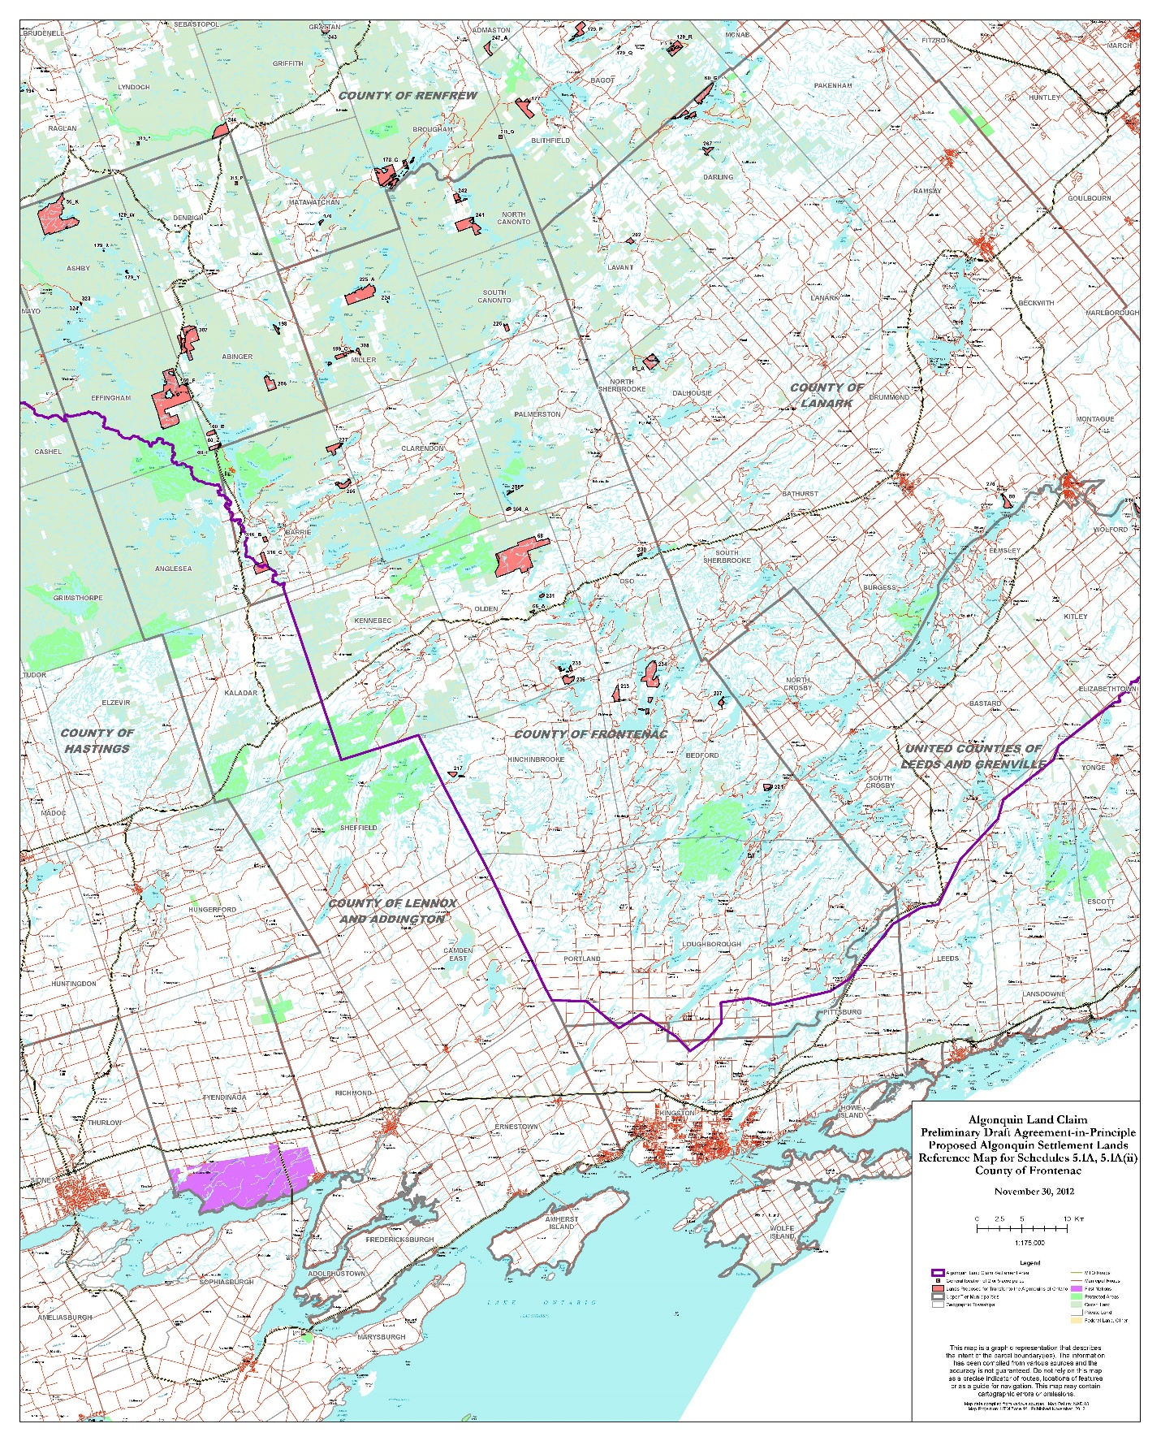
Figure 6
Algonquin Land Claim Territory
6.4 Rideau Canal UNESCO World Heritage Site
The Rideau Canal National Historic Site and UNESCO World Heritage Site, administered by Parks Canada, travels through the southeast portion of South Frontenac Township. The canal’s value lies in a combination of the engineering and military achievement of the construction of the canal and the associated canal structures and buildings, the continuity and integrity of the lockstations, its continuous seasonal operation since 1832, and the unique historical environment, which together constitute a cultural heritage resource of national significance and outstanding universal value. Parks Canada’s jurisdiction includes the bed of the canal up to the upper controlled water elevation and the lockstations.
In order to recognize and protect the cultural heritage resource significance of the Rideau Canal UNESCO World Heritage Site, the County has participated in an initiative, the Rideau Corridor Landscape Strategy, along with representatives from First Nations, federal and provincial agencies, municipalities, non-governmental organizations, property owners and others. A goal of the Strategy is to develop and recommend planning and management tools for municipalities and other jurisdictions that:
a) identify and protect the cultural heritage landscapes, Algonquin history, and built heritage resources of the waterway;
b) introduce design guidelines that can be implemented through the site plan control process, for new development along the waterway; and
c) identify measures to conserve the terrestrial and marine archaeological resources of the Rideau Canal.
Both this Plan and the South Frontenac Township Official Plan will recognize the policy directions coming out of this Strategy.
6.5 Frontenac Arch UNESCO Biosphere Reserve
The Frontenac Arch can be described as an ancient granite ‘bridge’ between the Canadian Shield and the Adirondack Mountains. Due to both its rich natural environment and its human history it was recognized in 2002 as a UNESCO World Biosphere Reserve.
The Frontenac Arch Biosphere lies on the Central Canadian portion of the Frontenac Arch. It covers approximately 2,700 sq km and covers part of both Frontenac County and the Leeds-Grenville County, including communities such as Brockville, Gananoque, Westport, Harrowsmith, Verona and Godfrey. Figure 7 illustrates the Biosphere area and its coverage within the Frontenacs.
It is the intent of this Plan to recognize the natural and historic value of the Frontenac Arch to our region and to promote its long term viability.
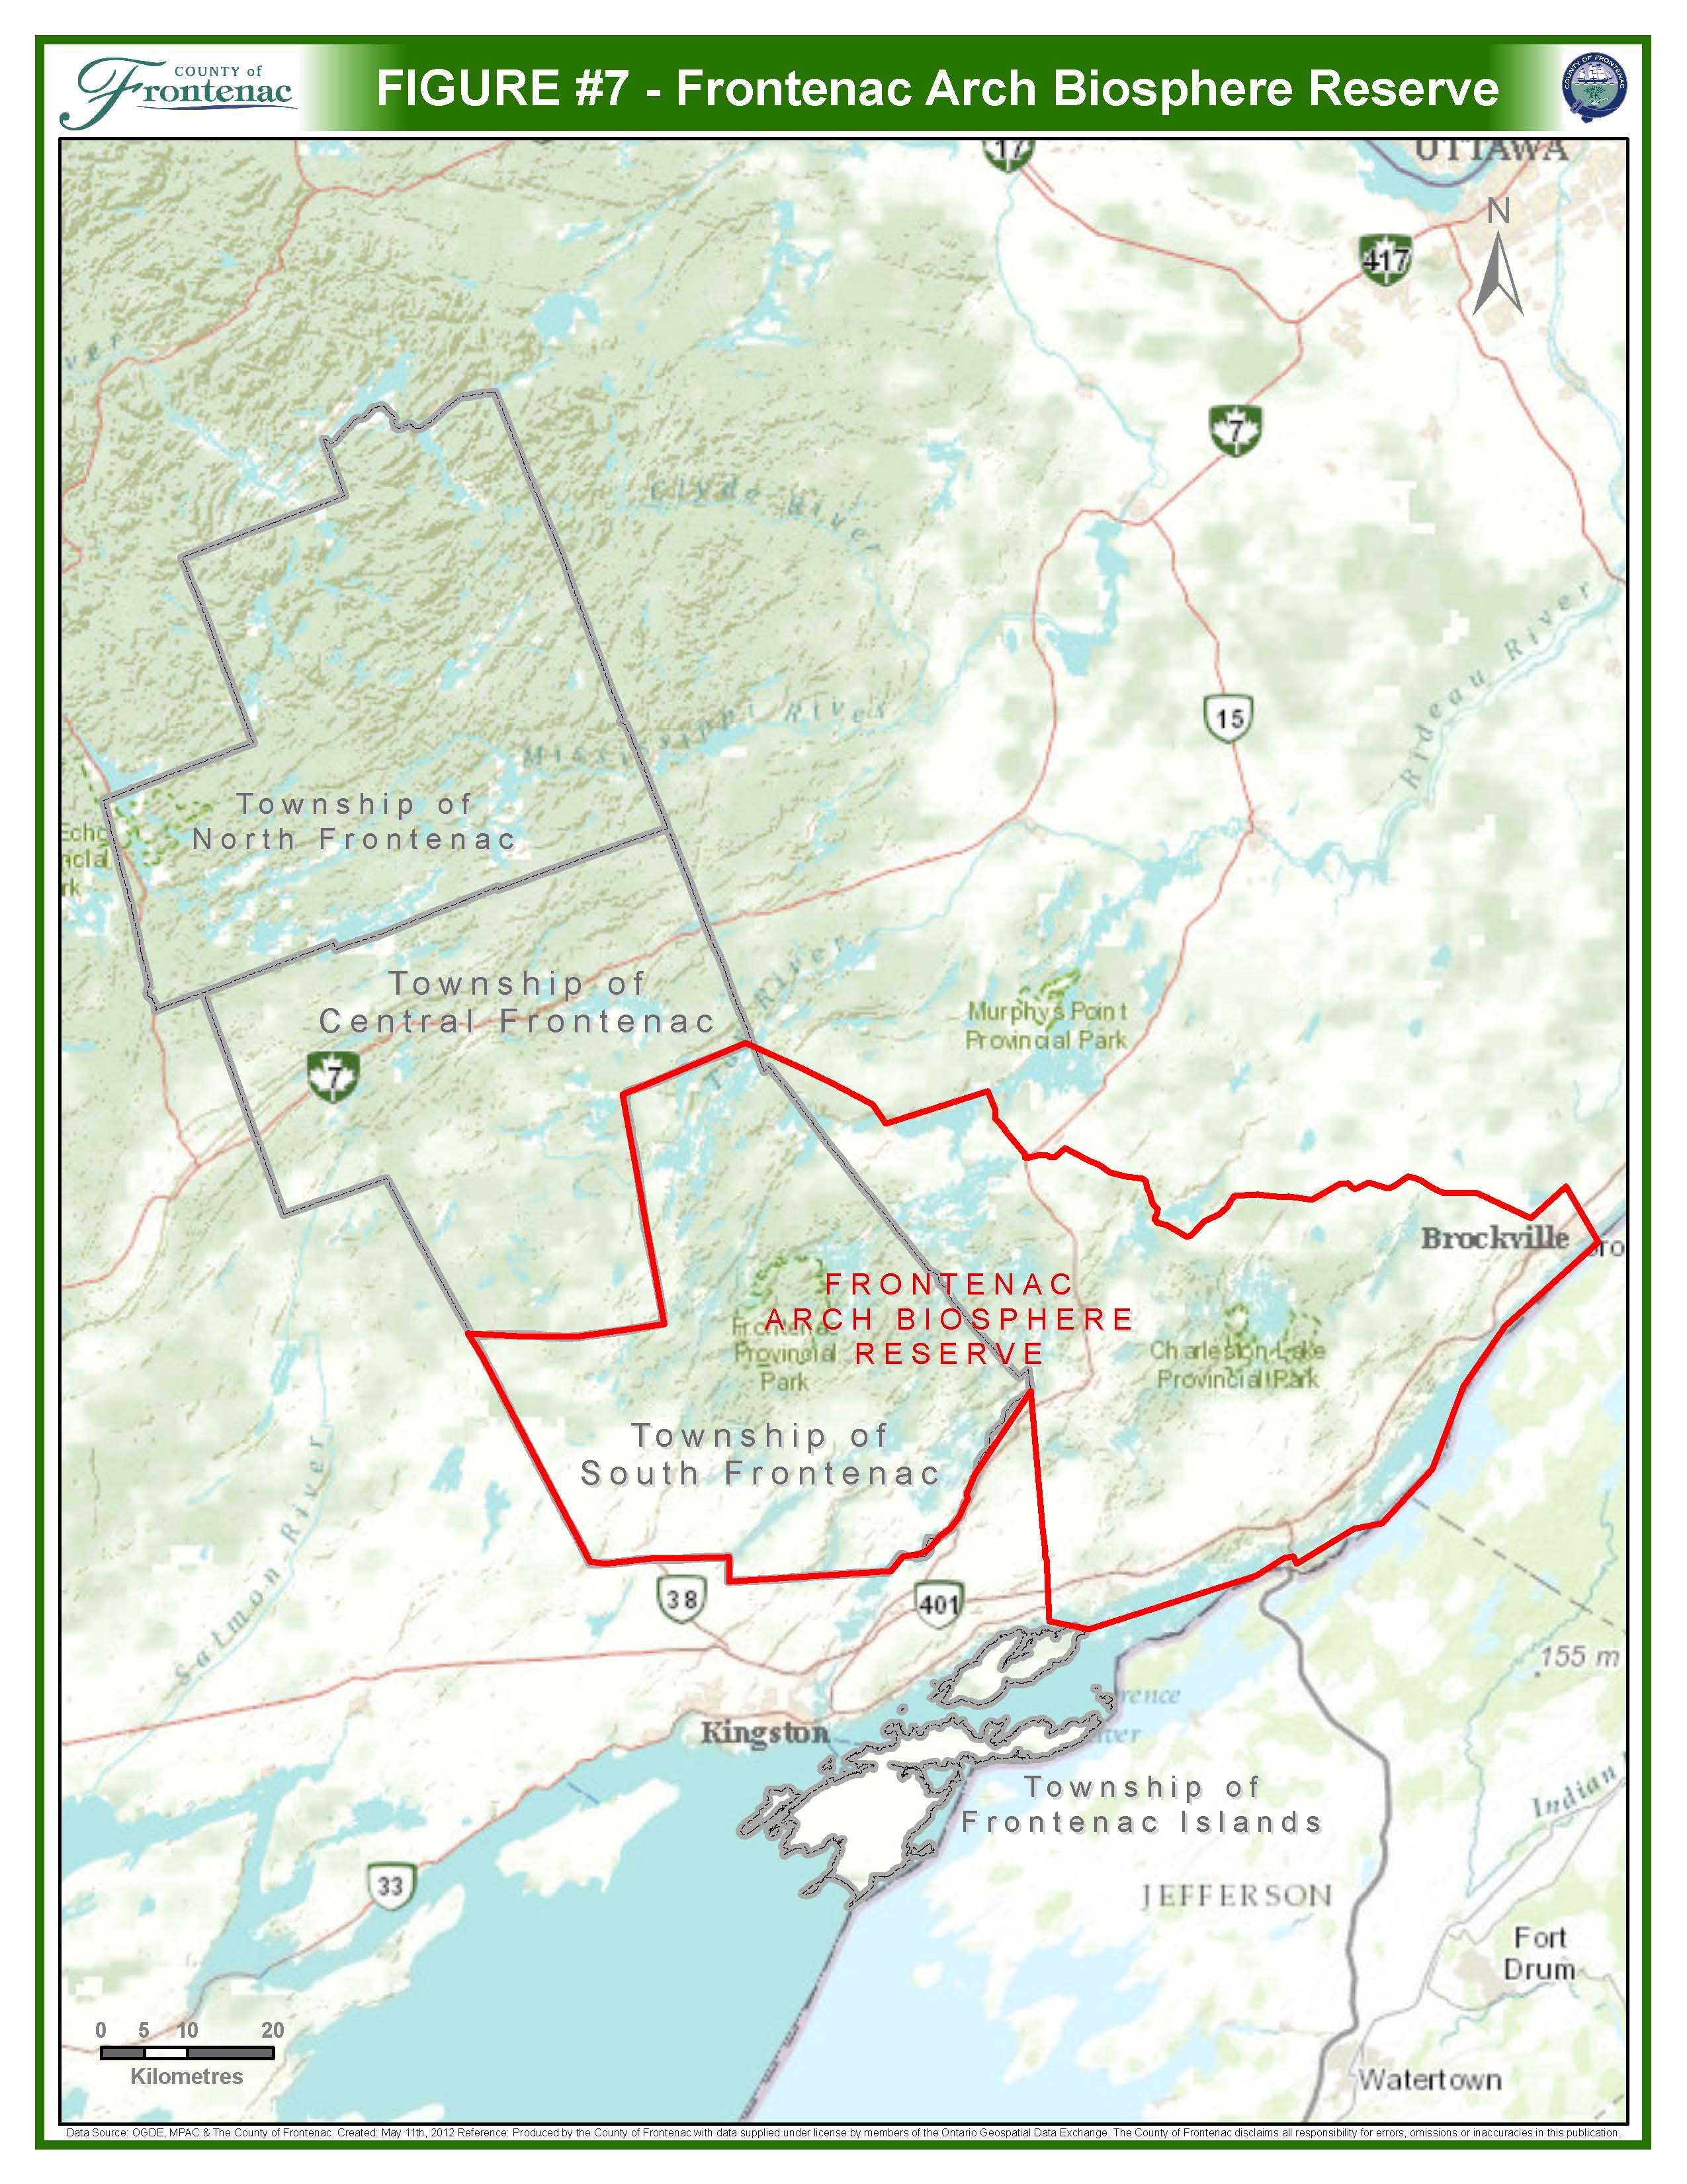

Section 7 – Environmental Sustainability
The County of Frontenac covers a large geographic area which is comprised of a rich natural environment that makes the region a unique place to live, work and play. This natural environment includes natural assets, natural sites, and natural attractions. The value of the natural environment for the County is more than just ecological health; it contributes to our economy and our society as well.
In addition to the Township Official Plans the following policy sections will apply:
- The Environmental Sustainability section sets out policies that are intended to help ensure that the environment that is so valued by residents in Frontenac County can be maintained and enhanced for future generations, and the health of humans and of the environment is protected.
- The Natural Environment section outlines the natural heritage system in the County and provides policies for protection of natural features in the Frontenacs.
- The Water Resources section includes policies recognizing the role of a watershed planning approach and of the importance of sourcewater protection plans in ensuring safe and plentiful drinking water.
- Hazard Lands Policies ensure that development is prohibited or strictly limited in areas that could have potential for natural hazards such as flooding and erosion.
7.1 Natural Environment
7.1.1 Introduction
The County of Frontenac natural heritage system is defined as an ecologically based delineation of nature and natural function – a system of connected, or to be connected, green and natural areas that provide ecological functions over a long period of time and enable movement of species. Natural heritage systems encompass or incorporate natural features, functions and linkages as component parts within them and across the landscape. A natural heritage system also supports natural processes which are necessary to maintain biological and geological diversity, natural functions, viable populations of indigenous species and ecosystems.
The natural heritage system illustrated on Appendices “1A”, “1B”, and “1C” use current standards and procedures such as the Natural Heritage Reference Manual (MNR 2010) and Provincial Policy Statement to identify natural features of interest, which include significant wetlands, significant coastal wetlands, fish habitat, significant woodlands, significant valleylands, habitat of endangered species and threatened species, significant wildlife habitat, and significant areas of natural and scientific interest.
Responsibility for the environment is shared among Federal and Provincial governments, the County, Townships, the Conservation Authorities (Quinte Conservation, Cataraqui Region Conservation Authority, Rideau Valley Conservation Authority, and Mississippi Valley Conservation) and private landowners. All have an important role in enhancing the natural environment within the County, and all have the responsibility to be good stewards. As a result, preserving a natural heritage system requires co-operation among agencies, private landholders and the wider community.
The natural heritage system, and the ecological functions it provides, contributes to maintaining the environmental health of the County of Frontenac. This Section of the Official Plan establishes a policy framework for a co-operative approach to the identification of the environmental features that comprise the natural heritage system. It also outlines how provincially and regionally significant features should be maintained, enhanced or, wherever feasible, restored and encourages the establishment of linkages among elements of the natural heritage system.
The natural heritage system is a layered approach to environmental protection comprised of features delineated on Appendices “1A”, “1B, and “1C”, and described in this section of the Official Plan. Each layer contains policies that provide appropriate protection to areas of environmental significance. Notably, the County of Frontenac’s natural heritage system includes natural linkages and biodiversity areas. Through linkages and biodiversity areas, we acknowledge that our system is not an isolated one. We are interconnected to the natural heritage beyond our boundaries and we value our local biosphere – the Frontenac Arch – as well as our global biosphere, Earth.
In this context it is important for Frontenac County to use a regional approach to ensure that significant natural heritage characteristics are protected for future generations.
Nothing in Section 7 is intended to limit the ability of the agricultural uses to continue.
(MMAH Approval dated January 11, 2016)
7.1.2 Goal
The goal of the natural heritage system is to work with the Province, Townships, the Conservation Authorities and private landowners to maintain, enhance and restore a comprehensive natural heritage system within the County.
7.1.3 Objectives
To achieve the goal of maintaining and enhancing a comprehensive natural heritage system, this Official Plan will:
- Identify and describe the component environmental features of the natural heritage system;
- Incorporate policies addressing land use and environmental preservation, conservation, and management that conform to the Provincial Policy Statement;
- Illustrate the natural heritage system on Official Plan mapping at the regional scale;
- Provide a mechanism for the refinement of the natural heritage system at the site-specific level;
- Identify, describe, and incorporate polices addressing County of Frontenac-specific natural linkages and biodiversity areas; and,
- Encourage local Townships to refine the natural heritage system to include important local features and linkages, where appropriate.
7.1.4 Policies
7.1.4.1 Wetlands
Introduction
Wetlands are an important part of the County’s biodiversity. They provide a wide variety of ecological, economic and social benefits for both humans and wildlife. Wetlands help reduce erosion, decrease flood damage, improve and maintain good water quality, provide important fish and wildlife habitat, ensure a stable, long-term supply of groundwater (by contributing to the recharge and discharge), provide recreation and tourism opportunities, limit greenhouse gas emissions (by acting as carbon sinks), and provide valuable economic products, such as timber, commercial baitfish, wild rice and natural medicines.
Council recognizes that the ecology of water systems contains a complex environment of plants, animals, and water which represents a highly valued resource in the Frontenacs, and that wetlands and riparian vegetation are part of the make-up of that ecology.
Policies
- The County of Frontenac recognizes the importance and value of wetlands in the County and supports their protection.
- Appendices “1A”, “1B”, and “1C” illustrate the County-wide natural heritage system, and generally identify provincially significant wetlands, coastal wetlands and significant other wetlands.
(MMAH Approval dated January 11, 2016)
- The Township Official Plans shall designate on a land use schedule and protect those wetlands where development and site alteration is prohibited. Including provincially significant wetlands and significant coastal wetlands. If at any time during the duration of this Plan any additional provincially significant wetlands are identified in the County of Frontenac by the Ministry of Natural Resources and Forestry (MNRF), the policies in this Plan and the Township Official Plans related to significant wetlands shall apply and the appropriate schedules shall be updated to reflect the new provincially significant wetlands without amendment to the plan.
(MMAH Approval dated January 11, 2016)
- The County of Frontenac encourages local municipalities to adopt mechanisms (such as site plan control, consent or development agreements) that would minimize and control the removal of vegetation, and ensure the protection of naturally vegetated buffers adjacent to any provincially significant wetlands.
- Other wetlands have also been identified on the Natural Heritage mapping in Appendices “1A” and “1B” and may also be identified on the Land Use Schedules of the Township Official Plans. Impacts on these wetlands should be considered in the evaluation of development applications in or adjacent to them, a wetland evaluation prepared by a qualified person in accordance with the Ontario Wetland Evaluation System and submitted to MNRF for approval and/or an Environmental Impact Study may be required if significant characteristics are observed and/or to demonstrate that appropriate alternatives have been assessed and negative impacts to the feature and its function have been prevented or minimized to the degree reasonably possible.
(MMAH Approval dated January 11, 2016)
- Development and site alteration shall not be permitted within lands adjacent to provincially significant wetlands or significant coastal wetlands unless the ecological function of the adjacent lands has been evaluated and it has been demonstrated that there will be no negative impacts on their features or their functions. Adjacent lands shall include lands contiguous to the wetland or areas where it is likely that development or site alteration will have a negative impact on the wetland. The extent of the adjacent lands shall be defined in the Township Official Plans, based on approaches recommended by the Province or based on Township approaches which achieve the same objective. (MMAH Approval dated January 11, 2016)
- Development and site alteration in or adjacent to coastal wetlands (other than significant coastal wetlands) shall not be permitted unless the ecological function of the adjacent lands has been evaluated and it has been demonstrated that there will be no negative impacts on their features or their functions. Adjacent lands shall include lands contiguous to the wetland or areas where it is likely that development or site alteration will have a negative impact on the wetland. The extent of the adjacent lands shall be defined in the Township Official Plans, based on approaches recommended by the Province or based on Township approaches which achieve the same objective.
(MMAH Approval dated January 11, 2016)
7.1.4.2 Significant Areas of Natural and Scientific Interest (ANSI)
Introduction
An ANSI is an area of land and water that contains natural landscapes or features that have been identified as having life science or earth science values related to protection, scientific study or education. ANSIs are a critical complement to Provincial Parks and Conservation Reserves as they represent important natural features that are not found in protected areas.
Policies
- The County recognizes the importance and value of regionally and provincially significant ANSIs and supports their protection. Appendix “1A” generally identifies ANSIs within the County’s natural heritage system.
- The Township Official Plans shall identify and protect those regional or provincially significant ANSI’s where no development shall permitted in or adjacent to them unless it can be demonstrated that there will be no negative impacts on the ANSI and its ecological function. Adjacent lands shall include lands contiguous to the ANSI or areas where it is likely that development or site alteration will have a negative impact on the ANSI. The extent of the adjacent lands shall be defined in the Township Official Plans, based on approaches recommended by the Province or based on Township approaches which achieve the same objective.
(MMAH Approval dated January 11, 2016)
7.1.4.3 Significant Wildlife Habitat
Introduction
Wildlife habitat, as defined by the PPS, means areas where plants, animals and other organisms live, and find adequate amounts of food, water, shelter and space needed to sustain their populations. Wildlife habitats are important since they are areas where species concentrate at a vulnerable point in their annual or life cycle, and are areas which are important to both migratory and non-migratory species.
Policies
- The County of Frontenac recognizes the importance and value of wildlife and supports the protection of significant wildlife habitat
- Appendix “1A" may identify the location of known wildlife habitat. Development and/or site alteration in or adjacent to significant wildlife habitat shall not be permitted unless it can be demonstrated that there will be no negative impacts on the significant wildlife habitat and its ecological function through an Environmental Impact Study. Adjacent lands shall include lands contiguous to the habitat or areas where it is likely that development or site alteration will have a negative impact on the habitat. The extent of the adjacent lands shall be defined in the Township Official Plans, based on approaches recommended by the Province or based on Township approaches which achieve the same objective.
(MMAH Approval dated January 11, 2016)
- Wildlife habitats occur throughout the County but may not be shown on Appendix “1A" because the exact habitat location needs to be refined at the local scale by site specific field work. If development or site alteration is planned in or adjacent to the natural heritage system, the proponent of the development may be required to document for consideration by the local Township, whether there is potential for significant wildlife habitat to occur in the area and whether an Environmental Impact Study is required to identify significant wildlife habitat for consideration during Planning Act decisions.
- The local Townships shall adopt appropriate development controls to protect significant wildlife habitat. If development or site alteration is planned near these sites, the local Townships may contact the Ministry of Natural Resources and Forestry (MNRF) for technical advice regarding the proposed development.
(MMAH Approval dated January 11, 2016)
- Natural linkages shall be protected in order to maintain, restore and/or improve the diversity and connectivity of natural features and the long-term ecological function and biodiversity of natural heritage systems.
- Removal of vegetation shall be minimized in significant wildlife habitat areas.
- The County and local municipalities shall investigate ways to minimize and control the removal of vegetation for buildings, site alteration or accessory activities such as landscaping.
7.1.4.4 Fish Habitat
Introduction
Fish habitat, as defined by the Fisheries Act, means spawning grounds and nursery, rearing, food supply, and migration areas on which fish depend directly or indirectly in order to carry out their life processes. The aquatic ecosystem is most often described as fish habitat since fish communities are important resources, and as such, have a long history of being used as indicators of aquatic ecosystem health. Aquatic habitat is an integral part of the watershed’s ecosystem as it provides feeding, breeding and rearing areas for resident and migratory fish and invertebrate species.
Policies
- The County of Frontenac recognizes the importance and value of the fisheries in the municipality and supports protection of their habitat.
- Development and/or site alteration in fish habitat shall not be permitted except in accordance with federal and provincial legislation and can be demonstrated through an Environmental Impact Study that there will be no negative impact on fish habitat and its ecological function.
- Development and site alteration in fish habitat shall require an Environmental Impact Study, to demonstrate that there will be no negative impacts on the fish habitat or on their ecological functions.
- New development along watercourses and waterbodies which have demonstrated no negative impact on the fish habitat or on their ecological functions shall require a minimum setback of 30 metres. These setbacks shall remain undisturbed and naturally vegetated, where possible.
- The County encourages the use of best management practices, stewardship and habitat management that promotes healthy fish habitat and natural riparian areas.
- Development and site alteration shall not be permitted within lands adjacent to fish habitat unless it has been demonstrated through an EIS that there will be no negative impacts to the features or functions of the habitat. Adjacent lands shall include lands contiguous to the fish habitat or areas where it is likely that development or site alteration would have a negative impact on fish habitat. The extent of adjacent lands shall be defined in the Township Official Plans, based on approaches recommended by the Province or based on Township approaches which achieve the same objectives.
7.1.4.4.1 Lake Trout Lakes
Preamble
Lake trout lakes are rare. While only about one percent of Ontario’s lakes (i.e. approximately 2,300) are designated by policy and managed by the Ministry of Natural Resources and Forestry (MNRF) for lake trout, this resource represents 20-25% of all lake trout lakes in the world. The lake trout is an important fishery resource in Ontario and Frontenac County and is a preferred species among many anglers.
(MMAH Approval dated January 11, 2016)
The lake trout is the only major, indigenous sport fish in Ontario that is adapted to “oligotrophic” lakes (i.e. lakes with low levels of nutrients, high dissolved oxygen levels and typically deep areas with very cold water). The lake trout’s slow growth, late maturity, low reproductive potential and slow replacement rate make it a unique species in the province. As a top predator, the lake trout is an important part of the province’s natural heritage and an excellent indicator of the health of these fragile aquatic ecosystems.
Approximately 5% of the province's lake trout populations have already become extinct. Lake trout and lake trout lakes are particularly vulnerable to the impacts of human activities including harvesting, increased phosphorus inputs from cottage septic systems and other sources of nutrient enrichment, acidification, species introductions, and habitat destruction. Development on lake trout lakes may result in habitat degradation, diminished lake trout populations and a lower quality fishing experience.
The Frontenacs, therefore, have a great responsibility to manage them wisely. The lake trout is particularly vulnerable to the impacts of human activities and is an indicator of the health of aquatic ecosystems. Special protection is required for these lakes and their lake trout populations.
Policies
- New lot creation shall not be allowed within 300 metres of at-capacity lake trout lakes located in Frontenac County. The list of such designated lakes are identified on Appendix “1B” and listed in Appendix “2” and shall be included in Local Official Plans.
- In consultation with the Ministry of Environment, the County will review and revise the list of at-capacity lake trout lakes in Appendix “2” on annual basis.
- Township Official Plans shall contain policies to protect these lakes, including the following:
  - Exceptions to the prohibition of development near at-capacity lakes, such as tile field setbacks;
  - Under such exceptional circumstances, new development requiring approval under the Planning Act that would, for example, prohibit removal of vegetation, require a 30 metre setback for all new buildings, or prohibit the use of fertilizers.
- The Townships are encouraged to identify the moderately sensitive at-capacity lake trout lakes in their Official Plans with policies addressing development around these lakes to ensure their long-term sustainability.
7.1.4.5 Endangered and Threatened Species
Preamble
Endangered and Threatened species, as defined by the PPS, means a species that is listed or categorized as an “Endangered or Threatened Species” on the Ontario Ministry of Natural Resources and Forestry (MNRF) official species at risk list, as updated and amended from time to time; Saving Endangered and Threatened species is important for their sake, and for ours since humans are dependent on the earth’s diversity of species for our own survival. The existing habitat sites of any endangered or threatened species in the County are not identified in this Plan or in Local Official Plans in order to protect endangered or threatened flora or fauna. (MMAH Approval dated January 11, 2016)
Policies
- The County of Frontenac recognizes the importance and value of the endangered and threatened species in the County and supports their protection.
- Habitat of endangered or threatened species is approved by the Province or the Federal government. This habitat is necessary for the maintenance, survival and/or recovery of naturally occurring or reintroduced populations of endangered or threatened species, and where those areas of occurrence are occupied or habitually occupied by the species during all or any part(s) of its life cycle. Mapping of the habitat of these species are not shown on Appendix “1C” in order to protect such species and their habitat, or because the exact location and habitat needs to be refined by site specific field work.
(MMAH Approval dated January 11, 2016)
- Information regarding occurrences of endangered and threatened species will be obtained from provincial databases and used, in confidence, for development application screening purposes. The Municipality recognized that information regarding the locations of endangered and threatened species and habitat is incomplete.
(MMAH Approval dated January 11, 2016)
- No new development or site alteration shall be permitted within the habitat of endangered or threatened species, except in accordance with provincial and federal requirements. Development and site alteration shall not be permitted on the adjacent lands of endangered or threatened species, unless it has been demonstrated through the preparation of an Environmental Impact Study that there will be no negative impacts on the natural features or on the ecological functions for which the area is identified. Adjacent lands shall include lands contiguous to the habitat of endangered and threatened specifies or areas where it is likely that development or site alteration will have a negative impact on the habitat. The extent of the adjacent lands shall be defined in the Township Official Plans, based on approaches recommended by the Province or based on Township approaches which achieve the same objective.
(MMAH Approval dated January 11, 2016)
- New development proposals shall require an appropriate level of site assessment to identify potential presence or absence of endangered or threatened species and their potential habitats. The MNRF can be contacted for technical advice.
(MMAH Approval dated January 11, 2016)
- Where potential habitat is identified, a more detailed site assessment may be required by an Environmental Impact Study to provide information on current habitat conditions, to address any applicable permit requirements under the Endangered Species Act (as appropriate), and to delineate significant habitat for approval by Ministry of Natural Resources and Forestry (MNRF).
(MMAH Approval dated January 11, 2016)
- No new development and/or site alteration shall be permitted within 120 metres of significant habitats of endangered and threatened species unless it has been demonstrated that there would be no negative impacts on the natural features or its ecological function.
- If development or site alteration is planned near these sites, the local Township shall contact Ministry of Natural Resources and Forestry (MNRF) for technical advice regarding the proposed development.
(MMAH Approval dated January 11, 2016)
7.1.4.6 Significant Woodlands
Preamble
Woodlands, as defined by the PPS, means treed areas that provide environmental and economic benefits to both the private landowner and the general public, such as erosion prevention, hydrological and nutrient cycling, provision of clean air and the long-term storage of carbon, provision of wildlife habitat, outdoor recreational opportunities, and the sustainable harvest of a wide range of woodland products. Woodlands include treed areas, woodlots or forested areas and vary in their level of significance at the local, regional and provincial levels. Woodlands are important for their aesthetic value, economic value, as species habitat, to minimize erosion, to mitigate greenhouse gases (as a carbon sink), and as providing animal species with corridors for movement.
Policies
- The County recognizes the importance and value of woodlands and supports the protection of significant woodlands. These woodlands have value in the County, both natural and human. Examples include maintaining and/or improving the air quality, preventing soil erosion, helping to retain water and recharge ground water, producing economic value (firewood, maple syrup, lumber), providing recreational opportunities, and contributing to the overall beauty of the Frontenacs.
- Appendix “1C” identifies all woodlands within the County, but does not identify any significant woodland.
- Township Official Plans within Ecoregion 6E shall identify and protect significant woodlands. These are to be identified using criteria established by the Ontario Ministry of Natural Resources and Forestry.
(MMAH Approval dated January 11, 2016)
- Development and/or site alteration in or adjacent to significant woodlands that may be identified in the majority of South Frontenac and all of Frontenac Islands (i.e., within MNR Ecoregion 6E of the PPS) shall not be permitted unless it can be demonstrated that there will be no negative impacts on the significant woodland and its ecological function. Adjacent lands shall include lands contiguous to the significant woodland or areas where it is likely that development or site alteration will have a negative impact on the woodland. The extent of the adjacent lands shall be defined in the Township Official Plans, based on approaches recommended by the Province or based on Township approaches which achieve the same objective.
(MMAH Approval dated January 11, 2016)
- When new significant woodlands are identified, consideration and protection of the areas shall be assessed prior to approving new land use planning applications.
7.1.4.7 Significant Valleylands
Preamble
Valleylands, as defined by the PPS, means a natural area that occurs in a valley or other landform depression that has water flowing through or standing for some period of the year. Valleylands are often defining landscape features essential to the character of an area, help buffer waterbodies from the effects of human settlement, provide linkages to the rest of the watershed, and provide important corridors allowing the dispersion of plants and movement of animals. Significant valleylands may be identified in the southern part of the County (i.e., within MNR Ecoregion 6E of the PPS).
Policies
- The County recognizes the importance and value of valleylands and supports the protection of significant valleylands.
- Significant valleylands are not shown on the Natural Heritage System mapping and can be identified in consultation with the Townships and/ or the local Conservation Authority based on local factors and conditions.
- The Township Official Plans shall contain policies that ensure that development and site alteration shall not be permitted in significant valleylands and its adjacent lands unless it has been determined, via an Environmental Impact Study, that there will be no negative impacts on the natural features or their ecological functions.
- The Township Official Plans shall contain policies that ensure that when new significant valleylands are identified, consideration and protection of the areas shall be assessed prior to approving new land use planning applications.
7.1.4.8 Linkages and Biodiversity Areas
Preamble
The County of Frontenac’s natural heritage system as mapped in Appendices “1A”, “1B”, and “1C” includes natural linkages and biodiversity areas. Through linkages and biodiversity areas, we acknowledge that our system is not an isolated one. We are interconnected to the natural heritage beyond our boundaries and we value our local biosphere – the Frontenac Arch – as well as our global biosphere, Earth.
7.1.4.8.1 Linkages
Preamble
The County of Frontenac is home to wildlife that traverses eastern Ontario and by identifying linkages; the County is able to support the valuable wildlife that contributes to the County’s high quality natural environment. The County has undertaken a geographic information systems (GIS) analysis to determine regional scale linkages.

Policies
- Linkages mapped in this plan on Appendix “1A” are intended to promote regional connectivity in the natural heritage system and the County of Frontenac encourages municipalities to establish and maintain linkages by incorporating them into their Official Plans.
- Where appropriate, the Townships are encouraged to add local linkages which facilitate greater connections between natural features of the natural heritage system.
- Linkage mapping has been completed at a regional scale, and the boundaries are intended to be refined at the site level. When development is proposed within a linkage, this plan encourages that linkages be incorporated into the development, retained in its natural state and an Environmental Impact Study be completed to document management recommendations for the protection of the linkage.
- Linkages may be considered as priority areas for ecological stewardship projects, re-naturalization projects, or environmental land acquisition projects, or as potential lands for conservation easements granted to the municipality by the property owner.
- Existing development and activities within linkages may continue.
7.1.4.8.2 Biodiversity Areas (Overlay)
Preamble
The County of Frontenac benefits from having a large undeveloped area that is rich in natural heritage and contains a wide range of species, habitats and ecosystems. Biodiversity Areas protect species, habitat and ecosystems that are representative of the County’s natural heritage system. Protecting biodiversity is a way to promote stewardship and ensure that impacts to the environment through challenges such as climate change are mitigated. The County has undertaken a geographic information systems (GIS) analysis to determine specific areas for the protection of biodiversity.
Policies
- Biodiversity areas are identified on Appendix “1A”.
- Biodiversity areas may receive priority consideration for the creation of new conservation areas, conservation easements, or new ecological stewardship programs;
- Notwithstanding the policies of the underlying land use designation, lands within Biodiversity Areas may be:
  - Discouraged from lot severance or subdivision unless immediately abutting existing development;
  - Discouraged from the creation of new buildings unless on an existing previously undeveloped lot; and,
  - If developed, encouraged to develop by minimizing changes to topography and vegetation, and by using materials and a built form that integrates well with a natural area.
7.1.4.9 Mineral Aggregate Operations
Policies
- New mineral aggregate operations may be permitted in the natural heritage system where the policies of this plan and the Township Official Plans allow and:
  - progressive and final rehabilitation shall be required to accommodate subsequent land uses, to promote land use compatibility, and to recognize the interim nature of extraction;
  - the assessment of the natural features and restoration plan taking into account the natural heritage system will be incorporated into the Natural Environment Report required under the Aggregate Resources Act.
7.1.4.10 Environmental Impact Study
Preamble
An Environmental Impact Study is an important tool used during the development review process which helps delineate, characterize, analyze, and plan for the protection and conservation of the natural heritage system and its components.
Policies
- Where the policies in this Plan provide for the preparation of an Environmental Impact Study EIS), it is understood that, on the basis of consultation with the appropriate review agency, the EIS may be scoped or eliminated in those instances where the potential impact of development is reduced or is non-existent.

- Where County Council is the planning approval authority, it shall require an impact assessment for development and site alteration proposed in designated natural heritage features and adjacent lands. An Environmental Impact Study shall be prepared to support land use planning applications and prior to the approval of the proposed development or site alteration. Depending on the type of planning application and the approval authority, the County, Townships and/or the Conservation Authorities will co-ordinate the requirements for the preparation of an Environmental Impact Study which shall be undertaken in accordance with the Natural Heritage Reference Manual and any other applicable guidelines.
- The potential scope required for the preparation of an EIS is listed in APPENDIX “3”.
7.1.4.11 Land Uses and Zoning
Policies
The County of Frontenac encourages the Townships to identify appropriate land uses and other performance standards in their Zoning By-laws that provide for protection of the features identified in the natural heritage system and which are compliant with the PPS.
7.1.4.12 Stewardship Planning
Introduction
One of the key factors that make Frontenac County such a unique place is that it is largely undeveloped, especially when compared to other parts of Ontario.
(MMAH Approval dated January 11, 2016)
(MMAH Approval dated October 21, 2016)
Policies
The County supports the development of a regional stewardship plan in order to provide a broad prospective on protecting ecosystems and managing landscapes.
This Plan recognizes that connectivity of landscapes and ecosystems is important for the long term resilience of the natural environment in the Frontenacs.
7.1.4.13 Lake Management Plans
Introduction
A Lake Management Plan (LMP) is an approach by a lake association to identify and protect the physical and environmental values of a lake or river system. A LMP can result in a long range vision for the lake community that can be implemented through stewardship direction and potential land use policies. County Council endorses the development of LMPs by lake associations, particularly those lakes that may be experiencing development pressure.
Policies
- Lake Management Plans may include a number of components, including:
  - A lake capacity assessment to help determine the carrying capacity for development and for opportunities to improve water quality;
  - An inventory of existing and proposed development by type, and characteristics of sewage and water services;
  - A shoreline capacity assessment to help determine lands which are suitable for development based on such features as slope, vegetation cover, and depth of overburden;
  - A fish habitat assessment;
  - The nature of public access and the use of the lake for aquatic and boating activities;
  - Road access to the lake or river for shoreline development;
  - Shoreline management practices that can provide direction for appropriate conservation or retention of natural features;
  - Identification of special attributes of the lake;
  - Public education; and
  - An implementation and monitoring program.
- Township Official Plans may include policies that identify Lake Management Plans that have been completed, recognizing that the primary use of these plans is for stewardship purposes.
7.2 Water Resources
7.2.1 Source Protection Plans
This Plan is based on a watershed planning approach. The Source Water Protection Plans were developed for each major watershed in the Frontenacs. The Quinte Source Protection Plan and the Mississippi-Rideau Source Protection Plans took effect January 1, 2015 and the Cataraqui Source Protection Plan took effect April 1, 2015. Decisions made under the Planning Act shall conform to the significant threat policies and have regard for other policies. The County supports the development of Source Protection Plans for each major watershed in the Frontenacs, including the Quinte Source Protection Plan, Cataraqui Source Protection Plan, and the Mississippi-Rideau Source Protection Plan. The Townships shall amend their Official Plans and Zoning By-laws as part of the implementation of source protection plans.
(MMAH Approval dated January 11, 2016)
The protection, conservation and careful management of groundwater resources is necessary to meet both the present and future needs of residents and the natural environment. As groundwater and aquifer contamination is extremely difficult and costly to rectify, prevention of contamination is the best strategy.
Policies
- The County shall:
- Support and participate in initiatives that implement the Clean Water Act, as necessary and appropriate;
- Prohibit the establishment of new waste disposal sites or wastewater treatment plants in the Sydenham intake protection zones 1 and 2 (As identified in the Cataraqui Source Protection Plan)
(MMAH Approval dated January 11, 2016)
- Where the County is the approval authority, require the submission of a notice from the Risk Management Official under Section 59 of the Clean Water Act with all planning applications or proposed land use changes in the Sydenham intake protection zones 1 and 2 (As identified in the Cataraqui Source Protection Plan)
(MMAH Approval dated January 11, 2016)
- Ensure that groundwater and surface water quality and quantity will not be negatively impacted by development in vulnerable areas for the protection of drinking water, including highly vulnerable aquifers and significant groundwater recharge areas (As identified in the Cataraqui Source Protection Plan);
(MMAH Approval dated January 11, 2016)
- Contribute and promote a culture of conservation among all public, private, community groups and local citizens and aim to reduce water use in all sectors;
- Establish sector-specific targets for water use reductions;
- Contribute and show leadership by considering water conservation and efficiency within its municipal culture, decision making, and operations.
7.3 Hazard Lands
7.3.1 Introduction
The County of Frontenac's long-term prosperity, environmental health and social well-being partly depends on reducing the potential for public cost or risk to Frontenac residents from natural or human-made hazards. Development should be directed away from areas of natural or human-made hazards where there is an unacceptable risk to public health or safety or of property damage.
7.3.2 Natural Hazards Policies
The County and the Townships shall consider the potential impacts of climate change that may increase the risk associated with natural hazards.
(MMAH Approval dated January 11, 2016)
7.3.2.1 Development shall generally be directed to areas outside of:
- hazardous lands adjacent to the shorelines of the Great Lakes - St. Lawrence River System and large inland lakes which are impacted by flooding hazards, erosion hazards and/or dynamic beach hazards;
- hazardous lands adjacent to river, stream and small inland lake systems which are impacted by flooding hazards and/or erosion hazards; and
- hazardous sites such as unstable soils (sensitive marine clays [leda], organic soils) or unstable bedrock (karst topography).
(MMAH Approval dated January 11, 2016)
7.3.2.2 Development and site alteration shall not be permitted within:
- the dynamic beach hazard;
- defined portions of the one hundred year flood level along connecting the St Lawrence River
- areas that would be rendered inaccessible to people and vehicles during times of flooding hazards, erosion hazards and/or dynamic beach hazards, unless it has been demonstrated that the site has safe access appropriate for the nature of the development and the natural hazard; and
- a floodway regardless of whether the area of inundation contains high points of land not subject to flooding.
7.3.2.3 Development shall not be permitted to locate in hazardous lands and hazardous sites where the use is:
- an institutional use associated with hospitals, nursing homes, pre-school, school nurseries, day care and schools, where there is a threat to the safe evacuation of the sick, the elderly, persons with disabilities or the young during an emergency as a result of flooding, failure of floodproofing measures or protection works, or erosion;
- an essential emergency service such as that provided by fire, police and ambulance stations and electrical substations, which would be impaired during an emergency as a result of flooding, the failure of floodproofing measures and/or protection works, and/or erosion; and
- uses associated with the disposal, manufacture, treatment or storage of hazardous substances.
7.3.2.4 Where the two zone concept for flood plains is applied, development and site alteration may be permitted in the flood fringe, subject to appropriate floodproofing to the flooding hazard elevation or another flooding hazard standard approved by the Minister of Natural Resources.
7.3.2.5 Further to policy 7.3.2.4, and except as prohibited in policies 7.3.2.2 and 7.3.2.3, development and site alteration may be permitted in those portions of hazardous lands and hazardous sites where the effects and risk to public safety are minor so as to be managed or mitigated in accordance with provincial standards, as determined by the demonstration and achievement of all of the following:
- development and site alteration is carried out in accordance with floodproofing standards, protection works standards, and access standards;
- vehicles and people have a way of safely entering and exiting the area during times of flooding, erosion and other emergencies;
- new hazards are not created and existing hazards are not aggravated; and
- no adverse environmental impacts will result.

7.3.2.6 Hazardous Forest Types for Wildland Fire
Development shall generally be directed to areas outside of lands that are unsafe for development due to the presence of hazardous forest types for wildland fire.

Development may however be permitted in lands with hazardous forest types for wildland fire where the risk is mitigated in accordance with wildland fire assessment and mitigation standards.
(MMAH Approval dated January 11, 2016)
7.3.3 Human-Made Hazards
Development on, abutting or adjacent to lands affected by mine hazards; oil, gas and salt hazards; or former mineral mining operations, mineral aggregate operations or petroleum resource operations may be permitted only if rehabilitation measures to address and mitigate known or suspected hazards are under-way or have been completed.
Contaminated sites shall be remediated as necessary prior to any activity on the site associated with the proposed use such that there will be no adverse effects.

Section 8 – Implementation
The intent of the Implementation section is to provide guidance when interpreting and implementing the policies of this Plan. This section includes policies relating to boundary interpretation, Official Plan amendments, subdivision and condominium applications, public participation, complete application requirements, land use compatibility, and development charges. These policies are intended to give direction to proponents when considering projects requiring approval by County Council, and to provide clarity to staff and Council when processing and evaluating development proposals.
8.1 Interpretation of Land Use Boundaries
It is intended that the boundaries of the land use designations shown on Schedule “A” be considered as approximate except where bounded by major roads, railways, water bodies, legal lot lines or other geographical features. Therefore, amendments to this Plan will not be required in order to make minor adjustments to the land use boundaries provided the general intent of the policies of this Plan is preserved.
8.2 Amendments to the Plan
Amendments to this Plan shall be considered in accordance with related policies elsewhere in this Plan, the Provincial Policy Statement, the Planning Act, and with general land use planning principles. Amendments shall only be considered when they are justified and when the required supportive information is provided as stated in the policy sector proposed for revision.
Proposed amendments to this Plan shall be accompanied by sufficient information to allow County Council to fully understand and consider the following:
1. the relationship to and impact of the proposed change on the goals, objectives and policies expressed in this Plan;
2. the need for the proposed change and the benefit to the County;
3. the effect of the proposed change on the need for public services and facilities;
4. the physical suitability of the land for the proposed use and the effect of the proposal on the natural environment; and
5. compliance with the Provincial Policy Statement and other applicable policy and legislation
Applications to amend this Plan will not be considered complete until the information and materials required under the Planning Act and Regulation 543/06, along with any other information and materials identified by the County have been provided.
The County may request the Minister to amend Ontario Regulation 525/97 to be exempt from ministerial approval of future amendments to the County Plan.
8.3 Amendments to the Township Official Plans
Amendments to Township Official Plans shall be considered in accordance with the Provincial Policy Statement, the policies in the County Official Plan, related policies elsewhere in the applicable Township plan, the Planning Act, and with general land use planning principles. Amendments shall only be considered when they are justified and when the required supportive information is provided.
Nothing in this Plan shall prevent the Townships from adopting more restrictive policies or standards than those outlined in this Plan, provided such policies are consistent with the general intent of this Plan.
8.4 Public Participation
Council shall consult with the public for amendments to and reviews of the Plan. The consultation process shall include the provision of adequate information in a timely manner, as well as opportunities for members of the public, review agencies, and other stakeholders to discuss this information with County staff and to present views to Council and to Township Councils.
When considering planning applications that are specific to one Township, the County will generally request that the Township hold any public meetings on the County’s behalf.
Under exceptional circumstances, Council may forego the requirement for a public meeting when refusing an amendment to its Official Plan.
8.5 Zoning By-laws
The preparation and amendments to Township Zoning By-laws shall be the responsibility of each Township Council. Each Zoning By-law shall reflect the policies established in the Township Official Plan.
8.6 Subdivision and Condominium Approvals and Agreements
The County of Frontenac is the approval authority for plans of subdivision and plans of condominium in the County under Ontario Regulation 477/00. This can include subdivisions for development in settlement areas, rural residential, commercial, and business park/industrial.
Council may delegate all or any part of the approvals process by By-law to a committee of Council or to staff.
Township Official Plans shall contain policies to guide the review of plans of subdivisions and plans of condominium.
Applications for plans of subdivision and condominium will not be considered complete until the information and materials required under the Planning Act and Regulation 544/06, along with any other information and materials identified by the County have been provided.
8.7 Planning Applications – Consultation and Complete Application Requirements
In situations where County Council acts as the planning approval authority, the County shall request additional information and material that it needs when considering development proposals or Planning Act applications. Such information may include but is not limited to any of the following:
- Hydrogeological and Terrain Analysis Report
- Water Supply Assessment
- Groundwater Impact Study
- Surface Water Impact Study
- Storm Water Management Report/Master Drainage Plan
- Environmental Impact Study/Statement
- Environmental Site Audit/Assessment
- Flood Plain Management/Slope Stability Report
- Geotechnical Karst Study
(MMAH Approval dated January 11, 2016)
- Lake Capacity Study
- Boat Capacity Study
- Transportation/Traffic Impact Study
- Municipal Servicing Capacity Reports
- Servicing Options Report
- Archaeological Resource Study
- Cultural Heritage Impact Statement
- Natural Heritage Evaluation
- Aggregate study
- Noise/Dust/Vibration Study
- Agricultural Soils Assessment Study
- Minimum Distance Separation calculation
- Market Study
- Planning Rationale
- Official Plan Amendment or Zoning By-law
- Concept Plan showing ultimate use of land
- Previous Land Use Inventory
- Financial Impact Report
- Any other studies required by the County which are not reflected in the above list
- Any other studies identified in the Township Official Plans
8.8 Development Charges
The County and any of the Townships may pass Development Charges By-laws in accordance with the Development Charges Act, 1997. Council may request that the City of Kingston collect development charges for applicable services provided by the County within the City’s boundaries.
8.9 Land Use Compatibility
Land use conflicts should be avoided as much as possible. Policies in Official Plans, setbacks in Zoning By-laws, and strategic design and layout of development applications can reduce the potential for conflicts by providing adequate mitigation measures to address issues before they arise.
Township Official Plans shall contain provisions addressing impacts such as noise, dust, contamination, odour, and other impacts that may result from a change in land use or proposed development.
Township Official Plans shall contain policies and guidance for setbacks for sensitive uses from features such as rail lines, mining and aggregate operations, and heavy industrial operations.

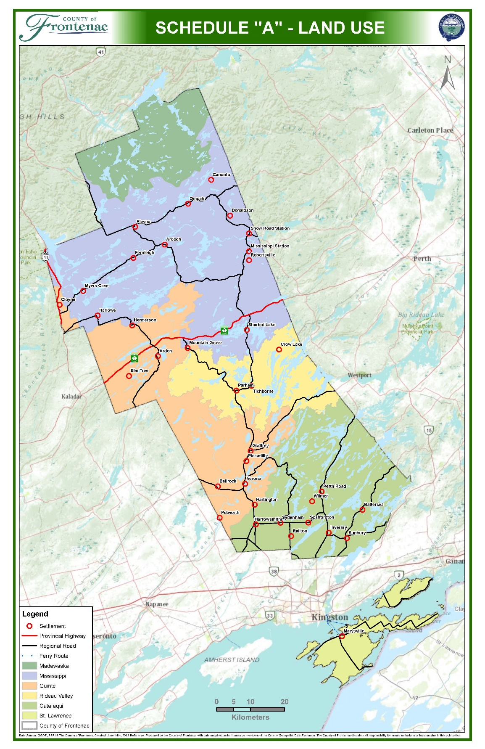

APPENDICES

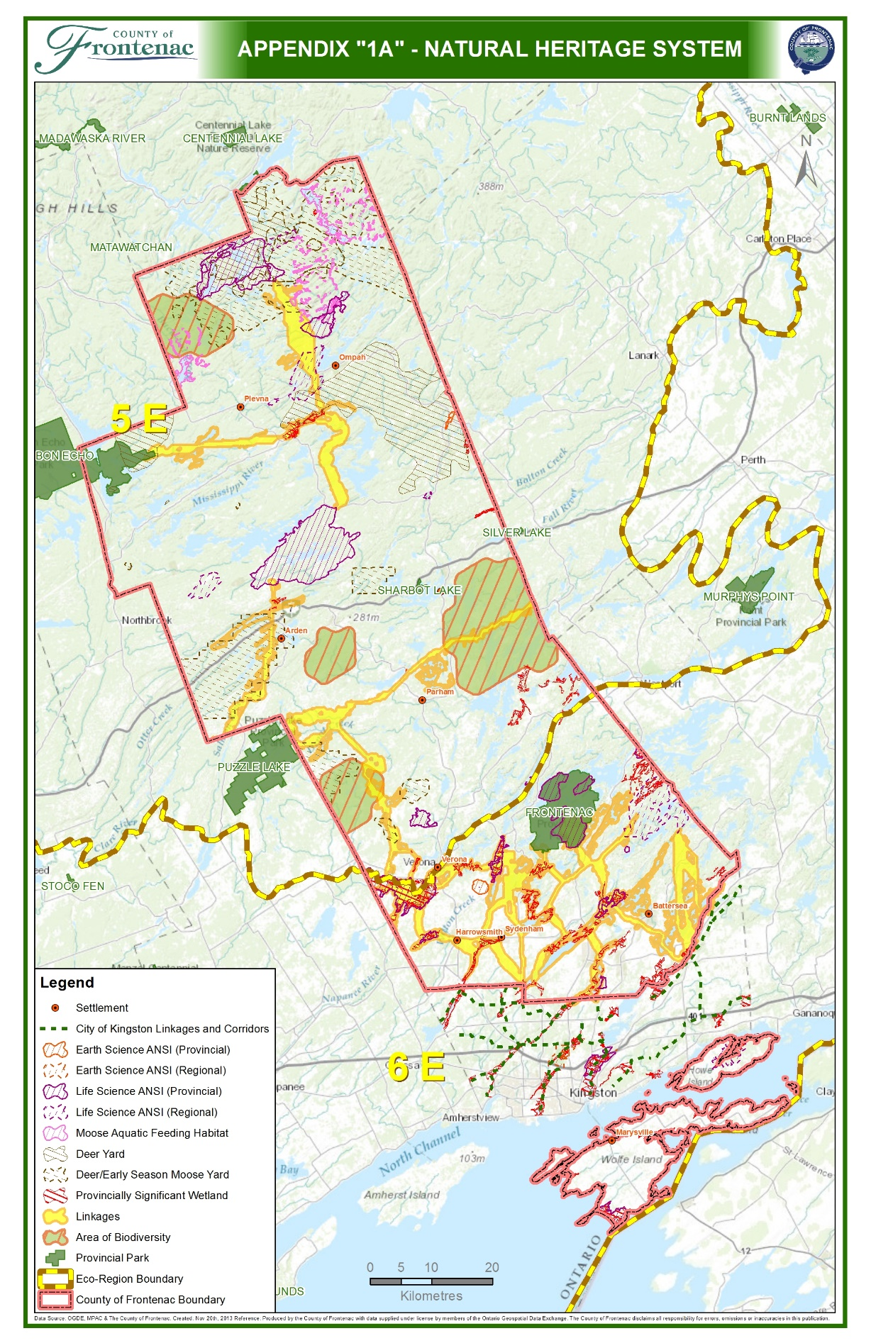
(MMAH Approval dated January 11, 2016)

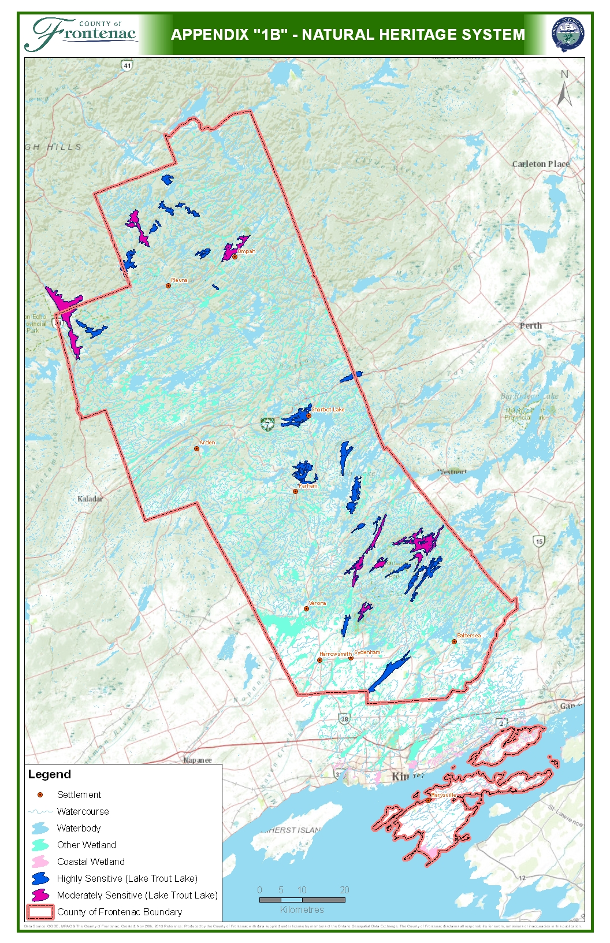
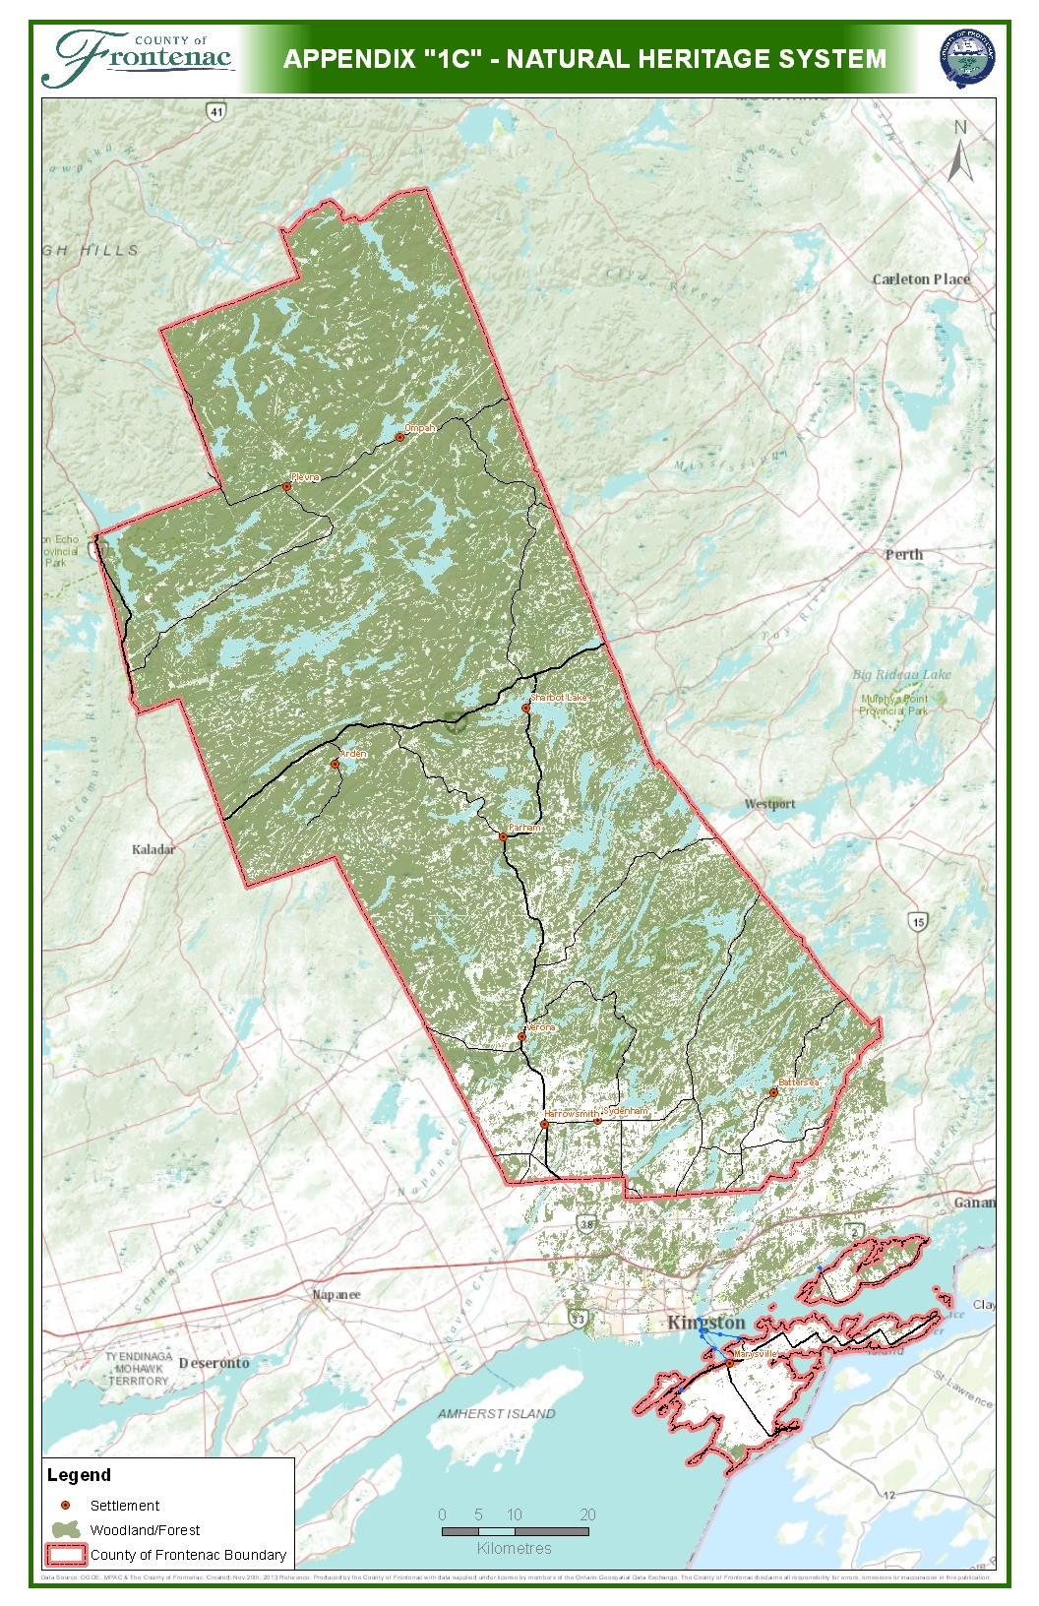
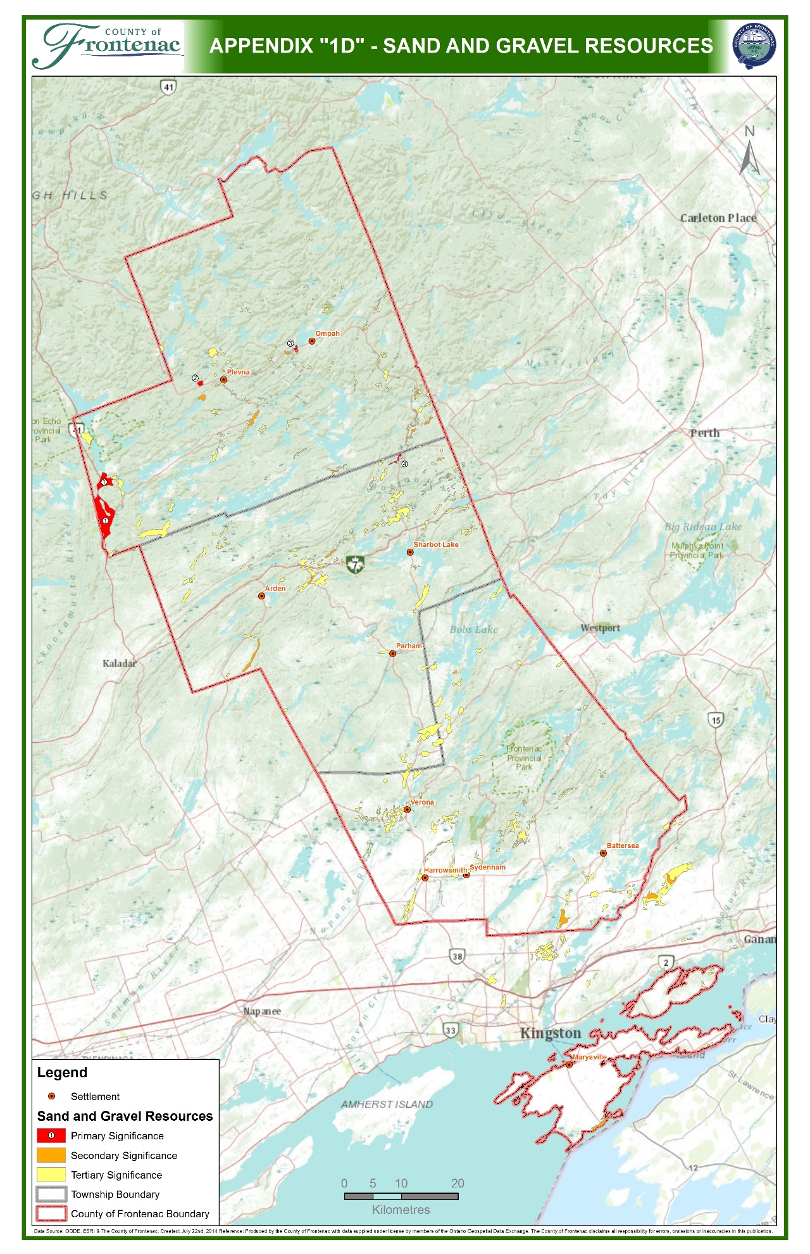
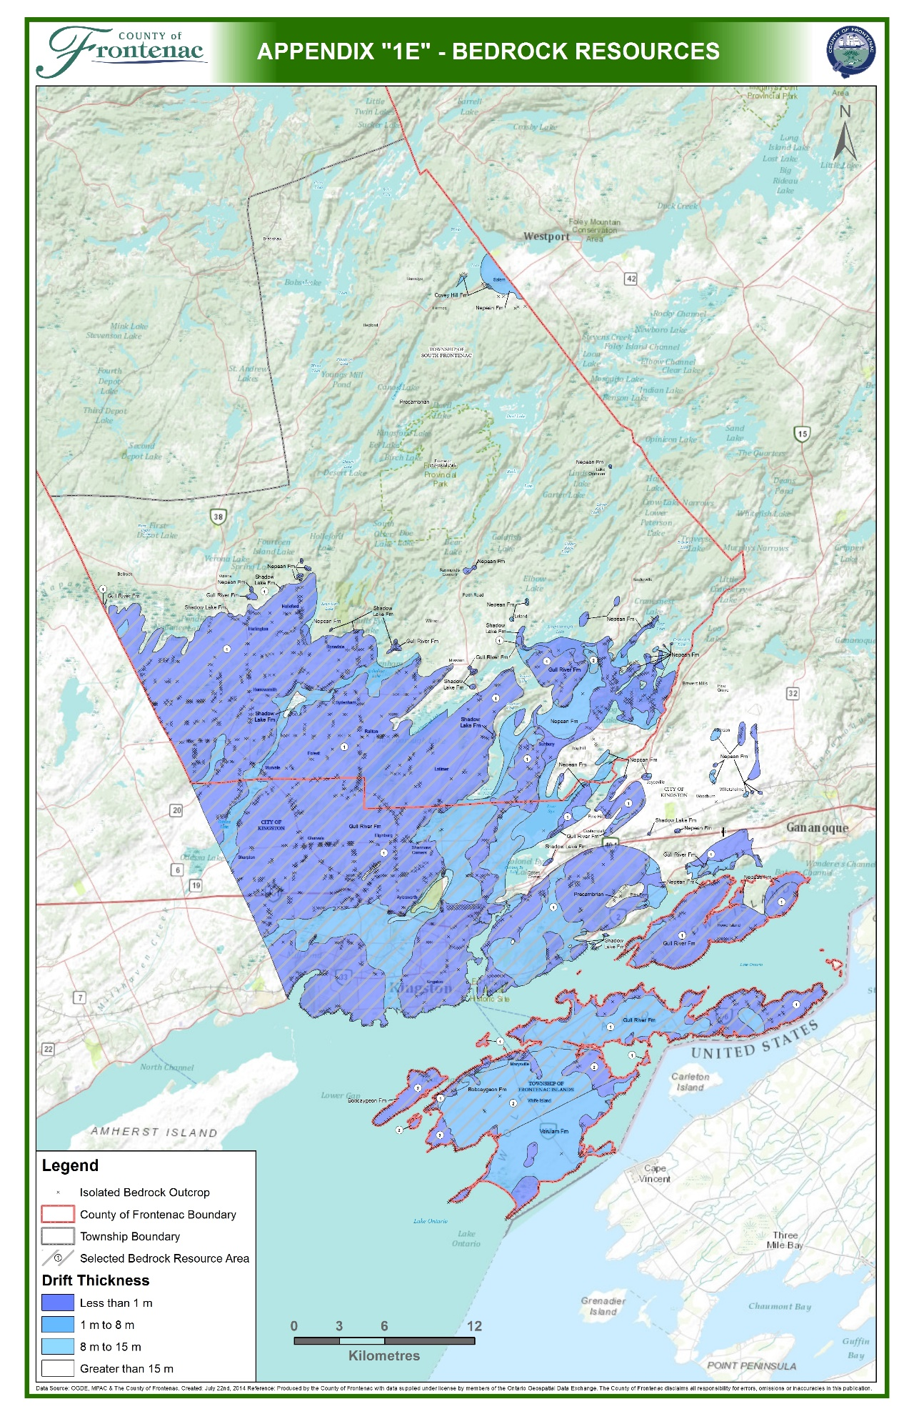
APPENDIX “2” – DESIGNATED ‘AT CAPACITY’ LAKE TROUT LAKES

- Shabomeka (Buck) Lake, Kishkebus (Dyers) Lake, Little Green Lake, Buckshot (Indian) Lake, Lucky Lake, Mosque (Mosquito) Lake, Big Ohlmann (Rock) Lake, Mackie Lake, Reid (Boundary) Lake, Round Schooner Lake, Camp (Little Mackie) Lake, Big Salmon Lake, Bobs (Green Bay) Lake, Buck Lake (South Frontenac), Crow Lake (Central/South Frontenac), Devil Lake, Eagle Lake, Garter Lake (near Potspoon Lake), Knowlton Lake, Loughborough (West Basin) Lake, Potspoon Lake, Sharbot (West Basin) Lake, and Silver Lake.
(MMAH Approval dated January 11, 2016)

“NOT AT CAPACITY” LAKE TROUT LAKES

- Big Clear Lake (South Frontenac), Birch Lake, Brule Lake, Canoe Lake, Desert Lake, Gould Lake, Mazinaw Lake, and Palmerston Lake.

APPENDIX “3” – ENVIRONMENTAL IMPACT STUDY REQUIREMENTS

- The County, in consultation with the Province, the local Townships and the Conservation Authorities may require the completion of a single comprehensive Environmental Impact Study where:
  - development or site alteration is proposed on multiple adjacent properties containing elements of the natural heritage system;
  - a comprehensive community planning process is being undertaken;
  - environmental studies are required to support the proposed expansion of the Township Urban Area or settlement boundary; or,
  - as deemed required by the County of Frontenac ,where the County is the approval authority.
- An Environmental Impact Study is intended to provide for an assessment of the potential impact of a proposed development or site alteration on a particular natural heritage feature and shall be used to determine whether the proposed development, redevelopment or site alteration should or should not be permitted. The Environmental Impact Study will be undertaken by the proponent of the development and/or site alteration.
- The components of the Environmental Impact Study shall be tailored to the scale of development and may range from a simplified assessment (scoped assessment) to a full assessment. The County may consult with the conservation authority having jurisdiction and the Ministry of Natural Resources and Forestry (MNRF) in determining information requirements and the type and content of an Environmental Impact Study. The following is intended to provide an initial guideline on the potential scope of an Environmental Impact Study:
(MMAH Approval dated January 11, 2016)
  - a description (including a map) of the study area and landscape context (including natural features and areas, and ecological functions);
  - a description of the development proposal;
  - date of field visits;
  - identification of the natural features
  - species lists of flora and fauna recorded for the site;
  - assessment of the potential impacts of the proposed development on natural features or areas and on their ecological functions for which they have been identified;
  - identification of alternatives and avoidance measures implemented to reduce impacts;

  - identification of mitigation, monitoring and contingency requirements;
  - quantification of residual impacts (those that cannot be mitigated) if any;
  - recommendations on how to implement mitigation measures; and,
  - conclusion(s) on the environmental impact(s).
- The County of Frontenac may prepare a comprehensive guideline for the preparation of and Environmental Impact Study which further implements this plan’s Environmental Impact Study policies.
- The Environmental Impact Study must be undertaken by a qualified professional to the satisfaction of the appropriate agency / approval authority.

