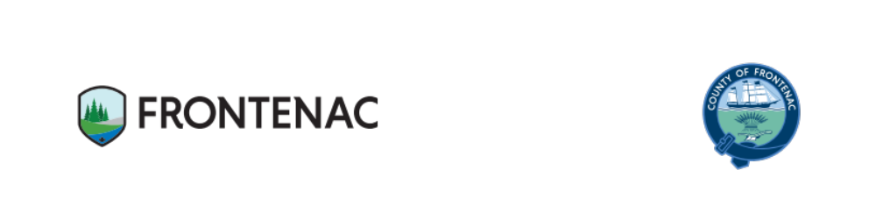Report 2025-031

Council Information Report
To: Warden and Members of County Council
From: Kevin Farrell, Chief Administrative Officer
Prepared by: Susan Brant, Administrator
Date of meeting: March 19, 2025
Re: Fairmount Home – Resident and Family Annual Satisfaction Survey 2024

Recommendation
This report is for information purposes only.

Background
The Fixing Long-Term Care Act (FLTCA), 2021, s. 43(1) states every license of a long-term care homes shall ensure that, unless otherwise directed by the Ministry, at least once in every year a survey is taken of the residents, their families and caregiver to measure their experience with the home and the care, services, programs, and goods provided at the home.

Comment

Resident Family Satisfaction Survey
Fairmount was one of eight (8) LTC homes that developed common satisfaction surveys for residents and families that met the homes’ requirements under the FLTCA as well as CARF Accreditation standards. There was an individual survey for residents and a separate survey for family members, Powers of Attorney (POA) or caregivers of residents. Survey respondents were able to complete the survey by hardcopy or online.
There were 449 survey responses (286 resident responses and 163 family responses) among the eight (8) LTC homes with an overall average score for residents of 93% and families/POA of 96%.
At Fairmount, there were 62 total survey responses which is a 6% increase in the number of Fairmount’s residents who responded when compared to 2023. In addition, the family members’ response rate decreased by 31% when compared to the previous year. Overall, Fairmount’s satisfaction survey results at 95% was marginally higher than the previous year (94%) and consistent with the other homes’ overall results (92%).
Management has reviewed the survey responses including the comments and will ensure that action is taken, as appropriate. The satisfaction survey results will be shared with Residents’ Council and Family Council. The Resident and Family Annual Satisfaction Survey Response Summary for 2024 is attached as appendix A.
Strategic Priorities Implications
3. Strengthen Quality of Life through Enhanced Service Delivery
- Focus on Fairmount Home
  - Improve the quality of care and services provided to residents.

Organizations, Departments, and Individuals Consulted and/or Affected
Residents, Families & Caregivers
Fairmount Management Team
Fairmount Staff

